Submitted by the experts from GTB | Informal document GRE-94-03  (94th GRE, 27-30 April 2026,  agenda item 6 (a))

This paper provides additional information and justification regarding document GRE/2026/6

I. Proposal for a Supplement to the 06, 07, 08 and 09 series of amendments to UN Regulation No. 48

Paragraph 2.4.10., amend to read:
“2.4.10. "Pair" means the set of lamps, of the same function on the left- and right-hand side of the vehicle. For vehicles of categories M, N and O, one or more lamp(s), used for the same function, extending from the left- to the right-hand side of the vehicle, is also considered a pair.”

Paragraph 2.4.11. and its sub-paragraphs, amend to read:
“2.4.11. "Single and multiple lamps"
2.4.11.1. "A single lamp" means:
…

(d) Any interdependent lamp system composed of two or more three interdependent lamps marked "Y" approved together and providing the same function.
2.4.11.2. "Two lamps" or "an even number of lamps" in the shape of a band or strip, means two lamps with a single light emitting surface, providing such a band or strip is placed symmetrically in relation to the median longitudinal plane of the vehicle. ”

Paragraph 2.4.12., amend to read:
“2.4.12. "Interdependent lamp system" means an assembly of two or more three interdependent lamps providing the same function.
2.4.12.1. "Interdependent lamp marked "Y"" means a device operating as part of an interdependent lamp system. Interdependent lamps operate together when activated, have separate apparent surfaces in the direction of the reference axis and separate lamp bodies, and may have separate light source(s).”

Paragraph 5.5. and its sub-paragraphs, amend to read:
“5.5. In the absence of specific instructions lamps constituting a pair shall:
5.5.1. Be fitted to the vehicle symmetrically in relation to the median longitudinal plane (this estimate to be based on the exterior geometrical form of the lamp and not on the edge of its illuminating surface referred to in paragraph 2.10.3.);
5.5.2. Be symmetrical to one another in relation to the median longitudinal plane, this requirement is not valid with regard to the interior structure of the lamp;
5.5.3. Satisfy the same colorimetric requirements;
5.5.4. Have substantially identical photometric characteristics. This shall not apply to a matched pair of a function and/or an AFS;
5.5.5. Be considered as two lamps;
5.5.56. In case of lamps incorporating a manufacturer logo, have only two lateral logos (one on each side) or one central logo can be fitted on the rear of the vehicle and only two lateral logos (one on each side) or one central logo can be fitted on the front of the vehicle. All logos that are not vehicle manufacturer or body manufacturer logos are prohibited.”

Paragraph 5.7.2.2., amend to read:
“5.7.2.2. Single lamps as defined in paragraph 2.4.11.1., subparagraph (b) or (c), composed of two lamps marked "D" or two independent retro reflectors, shall be installed in such a way that:
(a) Either the projection of the apparent surfaces in the direction of the reference axis of the two lamps or retro reflectors occupies not less than 60 per cent of the smallest quadrilateral circumscribing the projections of the said apparent surfaces in the direction of the reference axis; or
(b) The minimum distance between the facing edges of the apparent surfaces in the direction of the reference axis of two lamps or two independent retro reflectors does not exceed 75 mm when measured perpendicularly to the reference axis.”

Paragraph 5.7.2.3., amend to read:
“5.7.2.3. Single lamps as defined in paragraph 2.4.11.1., subparagraph (d) shall fulfil the requirements of paragraph 5.7.2.1.
Where two or more lamps and/or two or more separate apparent surfaces are included into the same lamp body and/or have a common outer lens these shall not be considered as an interdependent lamp system.
However, a lamp in the shape of a band or strip may be part of an interdependent lamp system.”

Paragraph 5.7.2.4., delete:
“5.7.2.4. Two lamps or an even number of lamps in the shape of a band or strip shall be placed symmetrically in relation to the median longitudinal plane of the vehicle, extending on both sides to within at least 0.4 m of the extreme outer edge of the vehicle, and are not less than 0.8 m long; the illumination of such a surface shall be provided by not less than two light sources placed as close as possible to the ends; the light-emitting surface may be constituted by a number of juxtaposed elements on condition that these individual light emitting surfaces, when projected on a transverse plane fulfil the requirements of paragraph 5.7.2.1.”

Paragraph 5.18.2., amend to read:
“5.18.2. In the case where the functions referred to in paragraph 5.18. are obtained by an assembly of two lamps marked "D" (see Paragraph 2.4.11.1.), only one of the lamps needs to meet the position, geometric visibility and photometric requirements for those lamps at all fixed positions of the movable components.
or”

II. Proposal for a Supplement to the 01 series of amendments to UN Regulation No. 148
Add new paragraph 4.7.3., to read:
“4.7.3. A pair, constituted of one or more light emitting surface(s), extending from the left- to the right- hand side of the vehicle, shall contain at least one light source on each side.”

Paragraph 4.8.1.3., amend to read:

“4.8.1.3. In case of a lamp (function) using light sources which are subject to more than one of the conditions prescribed in paragraph 4.8., the photometric measurements shall be made separately, in accordance with each applicable condition(s) set forth in paragraph 4.8..

All separate measurement results shall be added together.

The test laboratory may require from the applicant samples allowing to supply operate the different light source(s) separately.”

Add new Paragraph 4.8.1.11., to read:
“4.8.1.11 At the request of the applicant and with the consent of the Technical Service, the applicant may provide samples that allow the operation of the left hand and/or right-hand side separately, in case of a lamp with one or more light emitting surface used for the same function, extending from the left- to the right-hand side of the vehicle.”

III. Justification
- This proposal wants to address a multitude of vehicle and lamp designs we can see nowadays on the road. The goal is to have for all parties a clarification about component regulation and installation regulation, in relation about what is seen by the driver/observer eyes.

- Below are some examples (not an exhaustive list) of possible lamp combinations. This new proposal addresses all of these designs with clear requirements that apply without the need for interpretation.
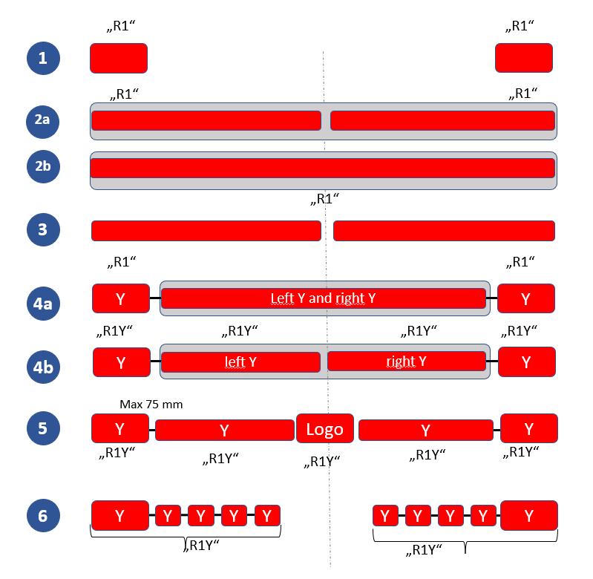

- Working Group Installation officers run a survey in 2020 with test houses to see their understanding about the current R48 when we have designs with a shape of band/strip. Answers are showing that the definition is not clear, especially when the shape is not exactly a line or when the lamp integrates a logo, whether in a dedicated device or not.

- The survey is also showing that the failure condition requirements that apply to this sort of band/strip and the way to power the lamp for testing during component approval is not clear and may deviate between different test houses.

- Idea of this proposal is to remove this wording of “band/strip” and to amend the definition of a pair of lamps to also cover the case when a lamp is used for the same function, that extends from the left to the right-hand side of the vehicle.

- The handling of parking lights (§6.12), which extend from the left to the right side of the vehicle, was also discussed. Are these also considered a pair? §6.12.9 actually states: “The functioning of this lamp may also be performed by simultaneously switching ON the front and rear position lamps on the same side of the vehicle. In this case, lamps that meet the requirements of front or rear position lamps are deemed to meet the requirements of parking lamps”. In the schematic of justification, paragraph 2, concept 2b or concept 4a, it may be not possible to switch off half of the lamp. In this case, for parking lamp solution may be to use §6.12.9 requirement and to keep left and right position lamp for parking lamp.

- To be technology neutral, the experts of GTB proposing to remove the maximum number of devices (3) for a Y-lamp. Today it is permitted to have designs with many (e.g. 5) distinct apparent surfaces in a single housing, so we do not understand why it is necessary to restrict the same surfaces from existing in many separate housings, since this has exactly same appearance to any driver/observer.

- The GTB experts chose the approach that a pair is a system with two lamps, so a new subparagraph §5.5.5 was added. This means that it is no longer necessary to amend every single point in §6.x.2 that prescribes two lamps, and confusion is avoided in designs similar to points 2A or 2B.

- Requirements about the number of light sources of such a lamp have been removed from R48 § 5.7.2.4 as component requirements should be in the component regulations, not the installation regulation. A new paragraph in component regulation R148, §4.7.3 now covers light source requirements, to guarantee there will be at least one light source in each side of the vehicle, so it will be impossible to do a design with a single light source.

- Specific requirement in R48 §5.7.2.4 about lamp positions have been removed, since lamp positions are already defined in paragraph 6.x.4 of R48, and we have decided to remove the minimum length of this sort of lamp (0.8 meter) considering that it was not technology neutral.

- Since definitions from R48 are also used in other installation regulations, it was specified in paragraphs 2.4.10. that they only apply to the correct vehicle categories.

- For paragraph 2.4.11 of R48 we do not need to mention marking, as this is covered in R148 Paragraph 3.3.2.5.2:

  - “If applicable, to the right side of the symbol mentioned in paragraph 3.2.4.:
(a) The additional letter "D", on lamps which may be used as part of an assembly of two independent lamps;
(b) The additional letter "Y" on lamps which are used as part of an interdependent lamps system.”
13. For UN Regulation No. 148 only slight amendments are necessary.
14. As the required number & position of light sources was removed from Par. 5.7.2.4. of UN Regulation No. 48, this was added accordingly to the provisions of a “pair” in Par. 4.7.3. of UN Regulation No. 148.
15. A minor clarification was necessary for Par. 4.8.1.3. as the word “supply” does not fully describe the requirements for the operation of a device.
16. For Par. 4.8.11. a new provision was added to reflect the necessary samples for the Technical Service to test the new band/strip versions more easily.

