Proposal for a supplement to the 02 series of amendments to UN Regulation No. 131 (Advanced Emergency Braking Systems (AEBS) for M2, M3, N2 and N3 category vehicles) and the 02 series of amendments to UN Regulation No. 152 (Advanced Emergency Braking System (AEBS) for M1 and N1 vehicles)

The text reproduced below was prepared by the experts from the United Kingdom of Great Britain and Northern Ireland and Australia which is looking to resolve issues with accepting the approval of M2, M3 and N2 vehicles to Regulation No. 152. The modifications to the existing text of the UN Regulation No. 131 and Regulation No. 152 are marked in **bold** for new characters and ~~strikethrough~~ for deleted characters.

I. Proposal for UN Regulation No. 131

*Paragraph 1.*, amend to read:

"

1. Scope

This Regulation applies to the approval~~*~~ of vehicles of Category M2, N2, M3 and N31 with regard to an on-board system to:

(a) Avoid or mitigate the severity of a rear-end in lane collision with a preceding vehicle,

(b) Avoid or mitigate the severity of an impact with a pedestrian.

~~* For vehicles of category M~~~~2~~~~, and for those of category M~~~~3~~~~/N~~~~2~~ ~~with a maximum weight below or equal to it, equipped with hydraulic braking, Contracting Parties that are signatories to both UN Regulation No. 152 and this Regulation shall recognize approvals to either Regulation as equally valid.~~ "

*Paragraph 4.*, amend to read:

"

4. Approval

4.1. If the vehicle type submitted for approval pursuant to this Regulation meets the requirements of paragraph 5. below, approval of that vehicle shall be granted.

**4.1.1. As an alternative at the request of the manufacturer, for vehicles of category M2, and for those of category M3 / N2 with a maximum mass below or equal to 8,000 kg, equipped with hydraulic braking, approval shall be granted if the vehicle type meets the requirements of paragraph 5. of the 02 or later series of amendments to UN Regulation No. 152, subject to the conditions in the following sub-paragraphs.**

**4.1.1.1 For the requirements of paragraph 5.1.7. of UN Regulation No. 152, the requirements of paragraph 5.1.7. of this Regulation shall apply.**

**4.1.1.2. For vehicles of category M2 and M3, the performance requirements in paragraph 5.2. of UN Regulation No. 152 corresponding to M1 category vehicles shall apply.**

**4.1.1.3. For vehicles of category N2, the performance requirements in paragraph 5.2. of UN Regulation No. 152 corresponding to N1 category vehicles shall apply.**

4.2. An approval number shall be assigned to each type approved; its first two digits (at present 02 corresponding to the 02 series of amendments) shall indicate the series of amendments incorporating the most recent major technical amendments made to the Regulation at the time of issue of the approval. The same Contracting Party shall not assign the same number to the same vehicle type equipped with another type of AEBS, or to another vehicle type.

4.3. Notice of approval or of refusal or withdrawal of approval pursuant to this Regulation shall be communicated to the Parties to the Agreement which apply this Regulation by means of a form conforming to the model in Annex 1 and documentation supplied by the applicant being in a format not exceeding A4 (210 x 297 mm), or folded to that format, and on an appropriate scale or electronic format.

4.4. There shall be affixed, conspicuously and in a readily accessible place specified on the approval form, to every vehicle conforming to a vehicle type approved under this Regulation, an international approval mark conforming to the model described in Annex 2, consisting of:

4.4.1. A circle surrounding the letter "E" followed by the distinguishing number of the country which has granted approval,3

4.4.2. The number of this Regulation, followed by the letter "R", a dash and the approval number to the right of the circle prescribed in paragraph 4.4.1. above.

**4.4.3. A dash and an additional symbol after the approval number:**

**4.4.3.1. "C" in the case where the approval is granted for a system to avoid or mitigate the severity of a rear-end in lane collision with a preceding vehicle (i.e., tested according to paragraph 5.2.1.);**

**4.4.3.2. "P" in the case where the approval is granted for a system to avoid or mitigate the severity of an impact with a pedestrian (i.e., tested according to paragraph 5.2.2.);**

**4.4.3.3. "X" in the case where the approval is granted according to paragraph 4.1.1. (if applicable).**

4.5. If the vehicle conforms to a vehicle type approved under one or more other Regulations, annexed to the Agreement, in the country which has granted approval under this Regulation, the symbol prescribed in paragraph 4.4.1. above need not be repeated; in such a case, the Regulation and approval numbers and the additional symbols shall be placed in vertical columns to the right of the symbol prescribed in paragraph 4.4.1. above.

4.6. The approval mark shall be clearly legible and be indelible.

4.7. The approval mark shall be placed close to or on the vehicle data plate."

*Paragraph 10. of Annex 1,* amend to read:

"10. Approval **granted/extended/revised/refused/withdrawn2**

10.1. **For system to avoid or mitigate the severity of a rear-end in lane collision with a preceding vehicle** ~~to vehicle to vehicle scenario granted/refused/extended/withdrawn~~: **yes/no**2

10.2. **For system to avoid or mitigate the severity of an impact with a pedestrian** ~~to vehicle to pedestrian scenario granted/refused/extended/withdrawn~~: **yes/no** 2

**10.3 Utilising the test requirements of Regulation No. 152 (according to paragraph 4.1.1.): yes/no2**"

*Annex 2,* amend to read:

"

Annex 2

Arrangements of approval marks

(See **paragraph** ~~paragraphs~~ 4.4. ~~to 4.4.2.~~ of this Regulation))

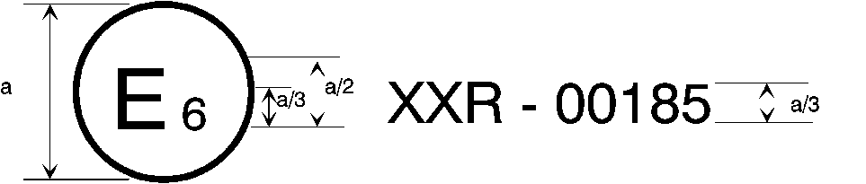

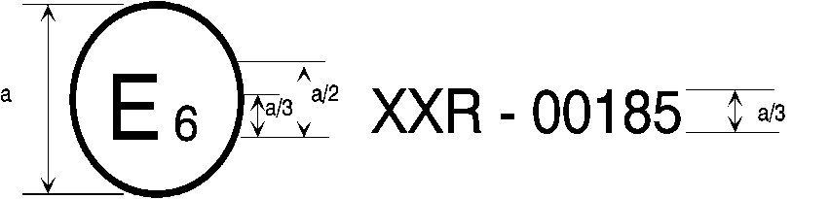

131R - 02185 - C

a = 8 mm min

The above approval mark affixed to a vehicle shows that the vehicle type concerned has been approved in Belgium (E 6) with regard to the advanced Emergency Braking Systems (AEBS) pursuant to Regulation No. 131 ~~(marked with C~~ for Vehicle to Vehicle **scenario**~~. P for Vehicle to Pedestrian)~~. The first two digits of the approval number indicate that the approval was granted in accordance with the requirements of UN Regulation No. 131 ~~in its original form~~ **incorporating the 02 series of amendments.**





131R - 02185 - XCP

a = 8 mm min

**The above approval mark affixed to a vehicle shows that the vehicle type concerned has been approved in Belgium (E 6) with regard to the advanced Emergency Braking Systems (AEBS) pursuant to Regulation No. 131 for Vehicle to Vehicle scenario and for Vehicle to Pedestrian scenario utilising the test requirements of Regulation No. 152. The first two digits of the approval number indicate that the approval was granted in accordance with the requirements of Regulation No. 131 incorporating the 02 series of amendments.**

"

II. Proposal for UN Regulation No. 152

*Paragraph 1.*, amend to read:

"

1. Scope

This Regulation applies to the approval of vehicles of Category M1 and N11~~*~~ with regard to an on-board system to

(a) Avoid or mitigate the severity of a rear-end in lane collision with a passenger car;

(b) Avoid or mitigate the severity of an impact with a pedestrian;

(c) Avoid or mitigate the severity of an impact with a bicycle.

~~* This Regulation also offers an alternative set of requirements for vehicles of Category M~~~~2~~~~, and for those of Categories M~~~~3~~~~/N~~~~2~~ ~~with a maximum weight below or equal to 8 tons, equipped with hydraulic braking, to those contained in UN Regulation No. 131.~~

~~For the vehicles described above, Contracting Parties that apply both UN Regulation No. 131 and this Regulation recognise approvals to either regulation as equally valid.~~ "

II. Justification

As has been highlighted by the expert from Australia, the reciprocal arrangement between UN Regulations No. 131 (R.131) and No. 152 (R.152) is not technically feasible due to a discrepancy between the scope of Regulations and the vehicle categories noted in the footnotes. In UN Regulations No. 13 (R.13) and No. 13-H (R.13-H), which was the inspiration for these provisions, vehicles of category N1 can be approved to the heavy-duty Regulation (R.13) because they are also within its scope.

The historical relationship between R.13 and R.13-H is also reflected within the EU type-approval framework where both Regulations are note for braking requirements. R.131 and R.152 were originally developed independently and also with a different focus for the type of scenarios to be address. This is alluded to by the fact that they are separate line items for Advanced Emergency Braking requirements. Consequently, even if an approval for a heavy-duty vehicle is issued to R.152, it still requires a change within the framework to be properly recognised. The reciprocal condition would also need to be replicated in every approval framework where it was expected to be exploited.

Where there is a permitted overlap in other Regulations, these still issue the approval to the main Regulation but point to the other Regulation as alternative requirements. Often it is the case that there are also constraints to control the application of the alternative requirements as would be the case here. An example of this if with UN Regulations No. 160 (R.160) and No. 169 (R.169). Certain heavy-duty vehicles, which typically are subject to R.169, can be approved to requirements of R.160 so long as they have a deployable restraint system (amongst other constraints). However, in the end an R.169 certificate is issued, albeit based on a test report to R.160, which makes it more straightforward process for acceptance by Contracting Parties.

This proposal is looking to utilise the arrangement from R.160 and R.169 (as well as other Regulations, such as UN Regulation No. 140) to make the reciprocal arrangement more robust and also better integrate within national and regional approval schemes. The conditions for approving a heavy-duty vehicle to R.152 in moved to approval requirements in paragraph 4. of R.131. This notes what vehicle can use those provisions and also what are the applicable requirements within R.152 for such vehicles. The certificate, which would be issued to R.131 based on an R.152 test report, is updated to note whether these provisions are used, as well as the approval marking to provide traceability and support any market surveillance activities. The line items in the certificate noting what capability the system has is also modified as vehicles are not granted/extended/withdrawn an approval for each scenario type, they are granted/extended/withdrawn an approval which is either to one or both scenarios.