 | United Nations | ECE/TRANS/WP.29/GRE/2026/14
 | Economic and Social Council |  | Distr.: General  10 February 2026  Original: English
Economic Commission for Europe
Inland Transport Committee
World Forum for Harmonization of Vehicle Regulations
Working Party on Lighting and Light-Signalling
Ninety-fourth session
Geneva, 27-30 April 2026
Item 7 (c) of the provisional agenda
Device UN Regulations:
UN Regulation No. 150 (Retro-Reflective Devices)
Proposal for a Supplement to the 01 series of amendments to UN Regulation No. 150
Submitted by the experts from The International Automotive Lighting and Light-Signalling Expert Group*
The text reproduced below was prepared by the experts from the International Automotive Lighting and Light-Signalling Expert Group (GTB) with the aim to align the marking location requirements with those of UN Regulation No. 148. The proposed modifications to the current text of the UN Regulations are marked in bold for new or strikethrough for deleted characters.

I. Proposal for a Supplement to the 01 series of amendments to UN Regulation No. 150
Paragraph 3.3.1.3., amend to read:
“3.3.1.3. With regard to the size of the approval marking the value for "a" is defined in Table 1.

Figure I
Approval markings proportions
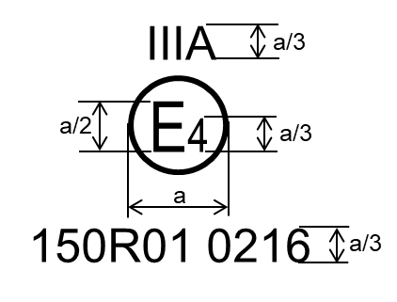
Examples of the arrangement of the markings are shown in Annex 10. ”

Paragraph 3.3.3.1., renumber “Figure I” to read “Figure II”
Figure A10-1, amend to read:

“ Figure A10-I: Marking examples for single devices

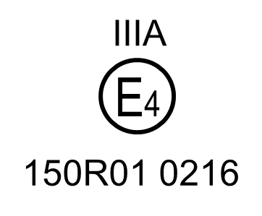 | Model A:  This approval mark affixed to a retro-reflective device shows that the type of device concerned has been approved in the Netherlands (E4) under approval number 150R01 0216. The approval number shows that approval was granted in accordance with the requirements of this Regulation as modified by the 01 series of amendments.  For a = see Table 1
…

Note: The above approval number and the group of symbols indicating the class must be placed close to, but in any position in relation to, the circle surrounding the letter "E". The digits constituting the approval number must face the same way as the "E". The group of symbols indicating the class must be diametrically opposite the approval number. The Type Approval Authorities shall avoid using approval numbers IA, IB, IIIA, IIIB and IVA which might be confused with the class symbols IA, IB, IIIA, IIIB and IVA.
These sketches show various possible arrangements and are given as examples only.”
II. Justification
The proposed amendment is intended to align the marking location requirements with those of UN Regulation No. 148. Further details can be found in informal document GRE-94-11.

* In accordance with the programme of work of the Inland Transport Committee for 2026 as outlined in proposed programme budget for 2026 (A/80/6 (Sect. 20), table 20.7), the World Forum will develop, harmonize and update UN Regulations in order to enhance the performance of vehicles. The present document is submitted in conformity with that mandate.

