**Proposal for amendments to working document GRSG/2025/51 (Draft Proposal for a new UN Regulation on the approval of a vehicle type with an advanced driver distraction warning system)**

The modifications to the document GRSG/2025/51 of the Regulation are marked in **bold** for new characters.

**I. Proposal**

*Paragraph 1,* amend to read:

"1. Scope

1.1. This Regulation applies to vehicles of category M and N.

1.2. This Regulation is without prejudice to requirements of national or regional laws related to privacy, data protection and personal data processing.

1.3. This Regulation does not apply to

1.3.1. vehicles of category X and Y**;**

1.3.2. **vehicles of category M and N** **where the "R" point of the driver seat is not more than 450 mm from ground level**.”

**II. Justification**

1. This proposal is aimed at allowing the certification for peculiar vehicle architectures (e.g. high-performance vehicles), where generally the "R" point of the driver seat is not more than 450 mm from ground level. **High-performance vehicles have peculiar characteristics**. For instance, in order to reduce the aerodynamic drag the frontal surface is reduced. This leads to specific architectural solutions such as thinner and very tilted “A” pillar, smaller field of view, low volume cabin compartment, compared to mass-market vehicles. As a consequence, for high performance vehicles:

* **installation of interior sensors for driver monitoring is challenging;**
* **components specifications,** as developed by Tier 1 suppliers **for mass-market applications, are not suitable** for such peculiar vehicle characteristics**.**

1. 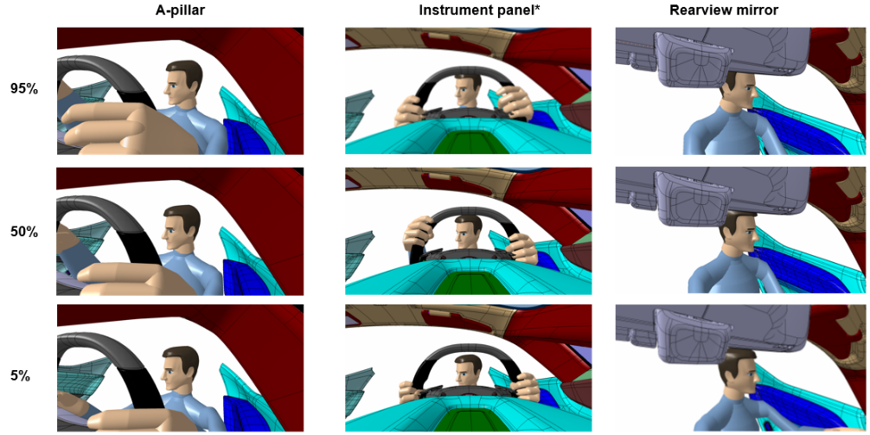At-the-date, ADDW systems are mainly based on a camera sensor able to monitor the driver’s gaze. In order to fulfil ADDW performance/testing requirements, camera-system should be able to monitor **both driver’s eyes**. Considering the peculiar cabin architecture of high performance vehicles (e.g. thinner and very tilted “A” pillar, smaller field of view, low volume cabin compartment), the following images show cases where the gaze of the driver, looking at the boundaries of the distraction zone as define by the GRSG/2025/51 proposal, is not fully visible (i.e. both driver’s eyes) for most common camera-installation positions in a car. This could lead to false positives, system unavailability.
2. In addition, high-performance vehicles have smaller frontal field of vision compared to mass market vehicles. Therefore, a reduced frontal area to fit information inside central cluster leads to challenging installation of ADDW camera.

_______