 | United Nations | ECE/TRANS/WP.29/GRE/2026/4
 | Economic and Social Council |  | Distr.: General  12 February 2026  Original: English
Economic Commission for Europe
Inland Transport Committee
World Forum for Harmonization of Vehicle Regulations
Working Party on Lighting and Light-Signalling
Ninety-fourth session
Geneva, 27-30 April 2026
Item 6 (a) of the provisional agenda
Installation UN Regulations:
UN Regulation No. 48 (Installation of Lighting and Light-Signalling Devices)
Proposal for a new Supplement to the 08 and 09 series of amendments to UN Regulation No. 48
Submitted by the expert from the International Organization of Motor Vehicle Manufacturers*

The text reproduced below was prepared by the experts from the International Organization of Motor Vehicle Manufacturers (OICA) with the aim to clearly prevent the approval of a manufacturer logo under UN Regulation No. 149. The proposal adds the possibility of substituting the part of the front position lamp with an adjacent adaptive front-lighting system (AFS) lamp in order to maintain the lit appearance of the vehicle in both day and nighttime conditions.
This document is a new proposal replacing ECE/TRANS/WP.29/GRE/2025/21 which was submitted to the ninety-third session of the Working Party on Lighting and Light-Signalling (GRE). The proposed modifications to the existing text of the UN Regulation are marked in bold for new or strikethrough for deleted characters.

I. Proposal
Paragraph 2.1.7., amend to read:
"2.1.7. “Manufacturer logo” means a light emitting graphic mark, emblem, word, or a combination of those elements, used to aid and promote public identification and recognition of a vehicle manufacturer's brand name when the function is switched ON."
Insert a new paragraph 5.12.1.4., to read:
"5.12.1.4. When a part of a front position lamp is substituted with an AFS lamp in accordance with paragraph 5.12.1., the remaining non-substituted part of the position lamp may remain switched ON provided that the distance to closest energised AFS lighting unit fulfils the requirements of paragraph 5.7.2.1."
Paragraph 5.30.1., amend to read:
"5.30.1. Especially in case of lLight-signalling deviceslamps incorporating a manufacturer logo, the lamp shall be type approved according to the 01 or subsequent series of amendments torequirements of the UN Rregulation No. 148."
Insert a new paragraph 5.30.2., to read:
"5.30.2. Road Illumination Devices approved to UN Regulation No. 149 shall not incorporate a manufacturer logo."
II. Justification
- Paragraph 2.1.7. clarifies that non-illuminated graphic marks or emblems are not considered as a manufacturer logo. It also addresses the need to respect the marking requirements in paragraph 3.3. of UN Regulation No. 149.
- Paragraph 5.12.1.4. permits vehicle manufacturers to keep the inner portion of the front position lamp switched on when an AFS headlamp substitutes the outer portion of the function. This avoids the need to regulate logos in UN R149. At this time manufacturers must activate the position lamp and dipped beam headlamp together if there is no substitution of the position function.
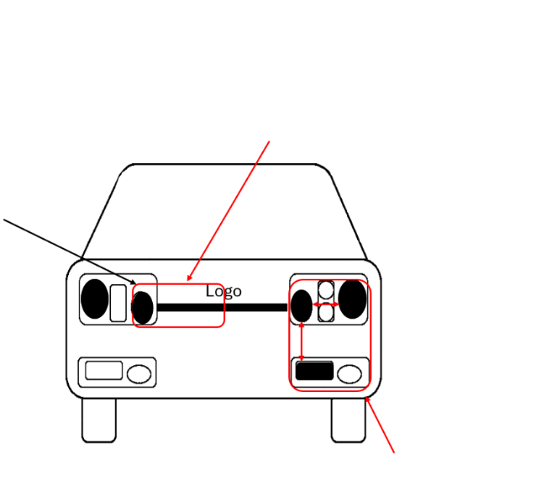
Figure
Front position lamp with an adjacent AFS lamp
The rules for single lamp apply when related to the position lamp

The closest energised lighting unit of an AFS in combination with the front position lamp that is not switched OFF form a single lamp. e.g. the 75mm requirement applies to all distances between fractions of the combined apparent surface.

The definition of the closest energised lighting unit is used because the opportunity to keep pat of the position lamp e.g. the one with the logo shall not require that all AFS lighting units cannot be arranged according to AFS needs (like 140 mm horizontal distance between AFS lighting units or 400 mm vertical distance).

The rules for AFS apply within the AFS

- Paragraph 5.30.1. improves the language of the text on logos for Light Signalling Devices approved to UN Regulation No. 148.
- Paragraph 5.30.2. clarifies that Road Illumination Devices approved to UN Regulation No. 149 shall not include a manufacturer logo.

* In accordance with the programme of work of the Inland Transport Committee for 2026 as outlined in proposed programme budget for 2026 (A/80/6 (Sect. 20), table 20.7), the World Forum will develop, harmonize and update UN Regulations in order to enhance the performance of vehicles. The present document is submitted in conformity with that mandate.

