**Proposal to amend working document GRBP/2025/29   
(Proposal for a Supplement to the 03 series of amendments of UN Regulation No. 51)**

Additional changes compared to document GRBP/2025/9 proposed by OICA are marked in **bold** for added text and ~~strike through~~ for deleted text, all in blue font.

Additional justifications compared to document GRBP/2025/9 are marked in green font.

**I. Proposal**

*Paragraph 2.29.*, amend to read:

"2.29. **“*Exterior Sound Enhancement System (ESES)*” means an active system that is installed on a vehicle for the purpose of producing exterior sound such as, but not limited to**

* **horns according to UN Regulations No. 28, or**
* ~~AVAS according to UN Regulation No. 138, or~~
* **Audible reverse warning device according to UN Regulation No. 165, or**
* **sound actuators, either integrated into an exhaust silencing system or mounted as an individual unit. "**

*Paragraph 6.2.3.,* amend to read:

"6.2.3. Additional ~~s~~**S**ound ~~e~~**E**mission ~~p~~**P**rovisions

The Additional Sound Emission Provisions (ASEP) apply ~~only~~ to vehicles of categories M1 and N1 ~~equipped with an internal combustion engine~~.

Vehicles are deemed to fulfil the requirements of Annex 7~~,~~ if the vehicle manufacturer provides technical documents to the type approval authority showing~~,~~ that the difference between maximum and minimum engine speed of ~~the~~ vehicles at BB' for any test condition inside the ASEP control range (as defined in paragraph 2.3. of Annex 7 ~~to~~**of** this Regulation ~~(~~including Annex 3 conditions) does not exceed 0.15 x S. This article is intended especially for non-lockable transmissions with variable gear ratios (CVT).

Vehicles are exempted from ASEP if one of the following conditions is fulfilled:

(a) For vehicles of category N1, if the engine capacity does not exceed 660 ccm and the power-to-mass ratio PMR calculated by using the technically permissible maximum laden mass does not exceed 35.

(b) For vehicles of category N1, if the payload is at least 850 kg and the power-to-mass ratio calculated by using the technically permissible maximum laden mass does not exceed 40.

(c) For vehicles of category N1 or M1 derived from N1, if the technically permissible maximum laden mass is greater than 2.5 tons and the R-point height is greater than 850 mm from the ground and the power- to-mass ratio calculated by using the technically permissible maximum laden mass does not exceed 40.

The sound emission of the vehicle under typical on-road driving conditions, which are different from those under which the type-approval test set out in Annex 3 and Annex 7 was carried out, shall not deviate from the test result in a significant manner.[1]

Any ~~electric sound enhancement system~~ **ESES** for the purpose of the exterior sound emission shall be operational during the type-approval test."

*Add a new paragraph 11.[xx].* to read:

**"11.[**~~xx~~**19]. Supplement** [~~yy~~**11**] **does not apply to existing type approvals and their extensions, granted prior to the date of entry into force of Supplement** [~~yy~~**11**]**"**

*Annex 3,*

*Paragraph 2.2.3.3.,* amend to read:

"2.2.3.3. ~~Active Sound Systems~~ **Exterior Sound Enhancement Systems (ESES)**

Any ~~active sound devices~~ **ESES**, either for noise control, or sound enhancement, shall operate as foreseen by the vehicle manufacturer and not be interfered with during the measurements."

*Paragraph 3.1.2.1.4.3.,* amend to read:

"3.1.2.1.4.3. Vehicles with only one gear ratio, like but not limited to Battery Electric Vehicles (BEV) and Fuel Cell Vehicles (FCV)

The gear selector position for forward driving shall be used. The acceleration value awot test shall be calculated as defined in paragraph 3.1.2.1.2.1.

The achieved acceleration awot test shall be greater or equal to aurban.

If possible, the manufacturer shall take measures to avoid an acceleration value awot test greater than 2.0 m/s².

Table 1 in Appendix to Annex 3 provides examples for valid measures to avoid accelerations beyond 2.0 m/s². Any measure used by manufacturer for the above-mentioned purposes shall be documented in the test report.

The achieved acceleration awot_test **, but not more than 2.0 m/s²,** is then used for the calculation of the partial power factor kp (see paragraph 3.1.2.1.3.) instead awot ref.**~~[For Annex 7~~** **~~calculations, the true achieved acceleration shall be used.]~~**

*Annex 7,*

*Add a new paragraph 1.1.,* to read:

"**1.1. Vehicles with propulsion technologies other than combustion engines shall comply with Analysis method 1[2] (Slope assessment method) only.**

**This shall apply as well to hybrid electric vehicles when tested without an operating combustion engine.**

**Manufacturers of vehicles, according to this paragraph, shall provide a statement of compliance for ASEP, confirming that the vehicle complies with the specifications described in paragraph 3.5. of this Annex, when tested with any operation condition within the control range in paragraph 2.3."**

*Paragraph 2.3.,* amend to read:

"2.3. Control ~~r~~**R**ange

The ASEP requirements apply to every gear ratio κ that leads to test results within the control range as defined below.

**The control range is specified as:**

|  |  |  |  |
| --- | --- | --- | --- |
|  | | **For vehicles according to Annex 7, paragraph 1.1.** | **For all other vehicles** |
| **Vehicle speed vAA_ASEP** | | **vAA > 0 km/h** | **vAA ≥ 20 km/h** |
| **Vehicle acceleration aWOT_ASEP** | | **aWOT ≤ 5.0 m/s2** | **aWOT ≤ 5.0 m/s2** |
| **Engine speed nBB_ASEP** | | **not applicable** | **nBB ≤ 2.0 * PMR-0.222 * S or nBB ≤ 0.9 * S, whichever is the lowest** |
| **Vehicle speed vBB_ASEP for vehicles tested in Annex 3 with** | | | |
|  | * **locked gear** | **vBB ≤ 80 km/h** | **If the vehicle, in the lowest valid gear does not achieve the maximum engine speed nBB_ASEP below 70 km/h, increase the vehicle speed in that gear to reach the maximum engine speed nBB_ASEP, but not beyond 80 km/h.**  **For any other gear, the maximum vehicle speed is 70 km/h.** |
|  | * **non locked gears** | **vBB ≤ 80 km/h** | **For vehicles tested in non-locked transmission conditions the maximum vehicle speed is 80 km/h.** |
| **Gear selection** | | **only if applicable, e.g. for hybrid electric vehicles:**  **gears κ ≤ gear i as determined in Annex 3** | **gears κ ≤ gear i as determined in Annex 3** |
| **Transmission condition for vehicles tested in Annex 3 with** | | | |
|  | * **locked gear** | **Geari, geari-1,…** | **Geari, geari-1,…** |
|  | * **non locked gears** | **Non locked gears** | **Non locked gears** |

~~Vehicle speed V~~~~AA_ASEP~~~~: v~~~~AA~~ ~~≥ 20 km/h~~

~~Vehicle acceleration a~~~~WOT_ASEP~~~~: a~~~~WOT~~ ~~≤ 5.0 m/s~~~~2~~

~~Engine speed n~~~~BB_ASEP:~~ ~~n~~~~BB~~ ~~≤ 2.0 * PMR~~~~-0.222~~ ~~* S or~~

~~n~~~~BB~~ ~~≤ 0.9 * S, whichever is the lowest~~

**For vehicles subject to paragraph 1.1. of this Annex,** **the manufacturer shall take measures to achieve an acceleration aWOT_ASEP within the acceleration control range.**

**Table 1 in Appendix 1 to Annex 3 provides examples for valid measures to enable a test condition within the above specified acceleration boundaries. Any measure used by manufacturer for the above-mentioned purposes shall be documented in the test report.**

~~Vehicle speed V~~~~BB_ASEP~~~~:~~

~~If the vehicle, in the lowest valid gear does not achieve the maximum engine speed n~~~~BB_ASEP~~~~below 70 km/h, increase the vehicle speed in that gear to reach the maximum engine speed n~~~~BB_ASEP~~~~, but not beyond 80 km/h.~~

~~For any other gear, the maximum vehicle speed is 70 km/h.~~

~~For vehicles tested in non-locked transmission conditions~~**~~,~~** ~~the maximum vehicle speed is 80 km/h.~~

~~Gears κ ≤ gear i as determined in Annex 3~~

~~Transmission conditions:~~

|  |  |
| --- | --- |
| *~~Annex 3 gear selection~~* | *~~Annex 7 gear selection~~* |
| ~~Locked~~ | ~~Gear~~~~i~~~~, gear~~~~i-1~~~~,…~~ |
| ~~Non-locked~~ | ~~Non-locked~~ |

"

*Paragraph 3.1.,* amend to read:

"3.1. Determination of the anchor point

The anchor point is the same for each gear ratio κ falling under the control range according to paragraph 2.3. The parameters for the anchor point are taken from the acceleration test of Annex 3 as follows:

In the case the test has been carried out with two gear ratios:

Lanchor isthe higher sound pressure level of Lwot,(i) of left and right side of gear ratio i;

nanchor is the average of nBB,wot of the 4 runs of gear ratio i reported from Annex 3;

**~~v~~~~anchor~~ ~~is the average of v~~~~BB~~~~,~~~~wot~~ ~~of the 4 runs of gear ratio i reported from Annex 3;~~**

**~~a~~~~anchor~~~~is the average of a~~~~wot,reptest~~ ~~of the 4 runs of the gear ratio i reported from Annex 3;~~**

In the case the test has been carried out in a single gear:

Lanchor isthe higher sound pressure level of Lwot of left and right side of gear ratio selected for the test;

nanchor is the average of nBB,wot of the 4 runs of gear ratio selected for the test reported from Annex 3;

**~~v~~~~anchor~~ ~~is the average of v~~~~BB~~~~,~~~~wot~~ ~~of the 4 runs of gear ratio selected for the test reported from Annex 3.~~**

**~~a~~~~anchor~~~~is the average of a~~~~wot,rep~~ ~~of the 4 runs of the gear ratio selected for the test reported from Annex 3;~~**

**~~a~~~~anchor~~~~is the determined acceleration and not restricted to 2.0 m/s² as provided from paragraph 3.1.2.1.4.3. Annex 3 for determination of the k~~~~p‑~~~~factor.”~~**

**In the case for vehicles subject to paragraph 1.1. of this Annex:**

**Lanchor isthe higher sound pressure level of Lwot of left and right side of gear ratio selected for the test;**

**vanchor is the average of vBB,wot of the 4 runs of gear ratio selected for the test reported from Annex 3, but limited to 60 km/h for further calculation.**

**aanchor is the average acceleration awot test reported from Annex 3, as defined in paragraph 3.1.2.1.2. of Annex 3;**

**aanchor is the measured acceleration and is not limited to 2.0 m/s² as provided from Annex 3 paragraph 3.1.2.1.4.3. for determination of the kp‑factor.”**

*Paragraph 3.2.2.,* amend to read:

"3.2.2. Slope of the regression line for each gear ratio κ

The slopeκ of a particular gear for the further calculation is the derived result of the calculation in paragraph 3.2.1. rounded to the first decimal place, but not higher than 5 dB(A)/1,000 min-1.

In case of non-locked conditions, if Slopeκ  < 0, the selected transmission setup is not valid. In that case the Lurban-Assessment as specified in paragraph 4. shall be applied.

**For vehicles subject to paragraph 1.1. of this annex, Slope**κ **shall be set to a constant value of 0,25 dB/km/h for further calculation.**"

*Paragraph 3.3.,* amend to read:

"3.3. Calculation of the linear sound level increase expected for each measurement

The sound level LASEP,κj for measurement point j and gear ratio κ shall be calculated using the engine speeds measured for each measurement point, using the slope specified in paragraph 3.2. above to the specific anchor point for each gear ratio.

For nBB_κ,j ≤ nanchor:

For nBB_κ,j > nanchor:

Where Y= 1

**In the case of vehicles subject to paragraph 1.1. of this Annex:**

**The sound level LASEP,κj for measurement point j and gear ratio κ shall be calculated using the vehicle speeds measured for each measurement point, using the constant slope specified in paragraph 3.2.2. above to the specific anchor point for each gear ratio.**

**For vBB_κ,j ≤ vanchor:**

**For vBB_κ,j > vanchor:**

**Where Y= 0,05**"

*Add a new paragraph 3.4.,* to read:

"**3.4. Calculation of the sound level increase regarding performance**

**For vehicles subject to paragraph 1.1. of this annex, the sound level ΔLASEP~~acc~~,κj for measurement point j and gear ratio κshall be calculated:**

**For all other vehicles the sound level ΔLASEP~~acc~~,κj is set to 0 dB.**"

*Paragraph 3.4. (former),* renumber:

"3.~~4~~**5**. Additional Samples"

*Paragraph 3.5. (former),* renumber and amend to read:

"3.~~5~~**6**. Specifications

Every individual sound measurement shall be evaluated.

The sound level of every specified measurement point shall not exceed the limits given below:

Lκj **- ΔLASEP~~acc,~~ κ,**j ≤ LASEP,κ.j + x

With:

~~x = 3 dB(A)~~ **~~+~~** ~~limit value[3] - L~~~~urban~~ ~~for vehicle tested with non-locked transmission conditions~~

x = 2 dB~~(A)~~ + **(**limit value³ - Lurban), ~~of Annex 3 for all other vehicles~~

**and only for vehicles**

* **tested with non-locked transmission conditions given by multiple gear ratios or**
* **having multiple electric propulsion sources or**
* **having an Lcrs_rep greater than Lwot_rep of Annex 3:**

x = 3 dB + (limit value[4] - L~~urban~~**urban**) of Annex 3

If **at any point** the measured sound level ~~at a point~~ exceeds the limit, two additional measurements at the same point shall be carried out to verify the measurement uncertainty. The vehicle is still in compliance with ASEP, if the average of the three valid measurements at this specific point fulfils the specification."

*Annex 9,*

*Paragraph 1.,* amend to read:

"1. General

The Real Driving Additional Sound Emission Provisions (RD-ASEP) apply only to vehicles of categories M1 and N1 equipped with:

- an internal combustion engine (ICE) for propulsion of the vehicle, or

- any other propulsion technology fitted with an ~~exterior sound enhancement system~~ **ESES**."

*Paragraph 2.2.,* delete.

~~“2.2. "~~*~~Exterior sound enhancement system~~*~~" means a system that is installed to a vehicle for producing exterior sound, such as but not limited to sound actuators, either integrated into an exhaust silencing system or mounted as an individual unit.”~~

*Paragraphs 2.3.,2.4. and 2.5.,* renumber and amend to read:

"2.~~3~~**2**. "*Deceleration*" **is defined as** ~~means~~ the vehicle deceleration stipulated by the release of the acceleration control unit only, without any driver applied braking (service brake, retarder, parking brake, etc…)."

"2.~~4~~**3**. "*Performance*" **is defined as** ~~means~~ the product of acceleration and vehicle speed as quantity of the achieved vehicle performance."

"2.~~5~~**~~4~~**. "*~~Power trains~~* ***Powertrain***" **is defined as** ~~means~~ a propulsion system as combination of the energy storage system, the energy supply system and the powertrain according to the UN Mutual Resolution No. 2 (for example PEV, HEV, FCHEV)."

**II. Justification**

1. This proposal has been worked out to close an existing gap in this Regulation as fast as possible. Therefore, this proposal uses the existing provisions of ASEP (Annex 7) for xEVs. OICA is still supporting the work of the related subgroup of the Informal Working Group on Real Driving - Additional Sound Emission Provisions (IWG RD-ASEP) and seeking for a consensus. But the possible entry into force within a short period of time is the main reason that leads OICA to present this proposal for adoption at the eighty-second session of GRBP, while OICA is still open for improvements or alternative approaches. Besides, the long-term solution is already in preparation with the work of the IWG RD-ASEP.

*Paragraph 2.29., Definition of Exterior Sound Enhancement System (ESES)*

1. This definition ensures that UN Regulation No. 51 stays design neutral. The list of examples shall not limit the definition, since expected new functions for child protection and thermal runaway, as well as the introduction of autonomous driving vehicles will probably require additional sounds in near future. The reference to AVAS and UN Regulation No. 138 has been deleted, since there is the objective that during the next update of the Regulation it will focus on whole vehicle sound and the expression AVAS could be obsolete.
2. This definition was developed by the IWG RD - ASEP to introduce a legal definition for devices, which are primarily introduced to modify and enhance the exterior sound of a vehicle. This definition aims at avoiding including components such as, but not limited to, fans or pumps that also emit sound. Such devices serve other functions.

*Paragraph 6.2.3., Specifications for Additional Sound Emission Provisions (ASEP)*

1. By introducing ASEP in Annex 7 in 2016 the scope was limited to vehicles with internal combustion engines (ICE) based on the experience of variabilities in the exhaust silencing systems. Electric vehicles (EVs) were exempted from ASEP.
2. For electric driven vehicles, UN Regulation No. 138, dealing with reduced audibility of these vehicles, was worked out until 2017. In lack of experience, the IWG on Quiet Road Transport Vehicles (QRTV) allowed the development of devices deemed necessary for safety, since at that time the discussion about the maximum needed operation range for AVAS was not agreed upon.
3. While the last amendment to UN Regulation No. 138 extended its specification range for AVAS systems to 50 km/h, and in parallel request was raised to enhance the ASEP control range to speeds lower than 20 km/h, the two Regulations provide parallel specifications for the same operation range.
4. UN Regulation No. 138 should remain a safety Regulation, and the environmental concerns should be addressed by the 03 series of amendments to UN Regulation No. 51. OICA proposes to apply ASEP to any vehicle having a sound enhancement system operational.
5. The aim of this proposal is to be effective and simple and to change as little as possible in the current ASEP concept. In the vision of OICA, this could be implemented as a Supplement to 03 series of amendments to UN Regulation No. 51. OICA deems this feasible as it will affect basically software and limited hardware changes.

*Paragraph 11.[xx]., Transitional provisions for this Supplement*

1. Supplement [11] introduces changes for ASEP introduced in Supplement 7. For electric vehicle types that were type approved before Supplement [11], the application of this supplement would require a new test. To avoid this unnecessary test burden, it is proposed not to apply these supplements to previous type approval and extensions granted prior to the date of entry into force of Supplement [11].

*Annex 3, paragraph 2.2.3.3. – Active Sound Systems*

1. The wording must be aligned to the new definition of “Exterior Sound Enhancement Systems (ESES)” introduced in paragraph 2.29.

*Annex 3, paragraph 3.1.2.1.4.3. – Calculation of kp-factor*

1. The partial power factor kp is used in the calculation of Lurban:

Lurban is calculated by a linear interpolation of Lcrs and Lwot. With the partial power factor kp every acceleration > aurban can be used for calculation of Lurban.

Lurban = Lwot– kP * (Lwot – Lcrs)

with kP = 1 – (aurban / awot test)

1. In Annex 3 tests the maximum acceleration awot test is limited to 2 m/s² only for calculation of kp, the effects of higher accelerations are not considered in the linear interpolation of Lurban anymore.
2. The sound dynamic of electric vehicles is rather low, compared to ICE vehicles. In combination with high achievable accelerations in Annex 3 the origin calculation of the partial power factor kp would lead to unnecessary higher tolerances. The limitation of the acceleration value for calculation of kp to 2.0 m/s² ensures that the anchor point for Annex 7 is related to urban driving.
3. The use of the suitable acceleration value (limited to 2 m/s² or true achieved) for calculation in Annex 7 is moved to Annex 7 and there described.

*Annex 7, new paragraph 1.1. – propulsion technologies other than combustion engines*

1. The extension of ASEP to battery electric vehicles (BEV) and hybrid electric vehicles (HEV) requires changes in Annex 7 to enable the evaluation of such vehicles according to ASEP.
2. The Reference Sound Assessment is not necessary, as it is based on the 02 series of amendments to UN Regulation No. 51 with very high limit values compared to the current technology of electric vehicles. Therefore, ASEP evaluation shall be limited to Analysis method 1 only; i.e. the slope assessment.
3. The sound dynamic of electric vehicles is rather low, compared to ICE vehicles, and therefore the assessment for Lurban would lead to unnecessary higher tolerances.
4. Some specificities of electric vehicles must be taken into consideration:
   * First, the circumstance that the acceleration performance could become much higher compared to ICE vehicle. Therefore, the tyre torque effect can play a greater role and may lead to sound levels that are significantly higher than the level of the anchor point.
   * Secondly, Supplement 8 introduced the case where Lurban = Lcrs_rep when Lcrs_rep is greater than Lwot_rep. This happens more frequently on electric vehicles. It results in a lower margin for ASEP, as the clearance to the limit value (i.e. the term limit value – Lurban in the equations of the margin x in Annex 7 paragraph 3.5.) is lowered and is not consistent to Lanchor, defined as Lwot_rep.
5. It is proposed to solve this by
   * Covering the EVs under the extended tolerance of 3 dB, same as for continuously variable transmission (CVT) vehicles in the slope assessment. See paragraph 3.6. of Annex 7.
   * A performance related adjustment of the measured sound level based on the provisions of RD-ASEP (Annex 9) in case of performances greater than the anchor performance. See paragraph 3.4. and 3.6. of Annex 7.

*Annex 7, paragraph 2.3. – “Control range”*

1. Since the used engine speeds for propelling electrical vehicles are different to the used engine speeds of ICE vehicles, the engine speed specifications of electric motors are not applicable here. The points P1 to P4 shall be determined based on the vehicle speed.
2. To expand the speed range of ASEP only for BEVs down to speeds > 0 km/h, avoids a mismatch of maximum sound limits at 20 km/h between UN Regulation No. 138 and UN Regulation No. 51.
3. While acceleration of ICE vehicles is limited by selecting the gear to be measured, in the case of electric vehicles, it ~~might be~~ is necessary to limit acceleration to 5 m/s² to enable ASEP tests. Therefore, the same provisions as in Annex 3 Table 1 shall be used for electric vehicles.
4. For better overview the content of the paragraph has been put into a table.

*Annex 7, paragraph 3.1. – Determination of the anchor point*

1. The border curve of ASEP is based on engine speed. EVs do not provide a meaningful engine speed for the purpose of ASEP. Therefore, the vehicle speed is used as a base for ASEP. With the vehicle speed, the Analysis method 1 needs some adoptions (see paragraph 3.2.2.).
2. To improve the structure of this paragraph, the definitions related to EVs have been gathered in a dedicated paragraph.
3. The vehicle speed at the anchor point is limited to 60 km/h. For some Type Approval Authorities and manufacturers, who do not want to limit the acceleration in Annex 3 WOT-test in regard to vehicle safety (no blocking of accelerator), the effect of moving the anchor point to higher speeds would lead to an unneeded burden. By limiting the speed this burden is also limited.
4. In addition, the acceleration used in the test of the anchor point is introduced. This acceleration aanchor is used with the vehicle speed vanchor to calculate the reference performance for the adjustment of the measured sound levels.

*Annex 7, paragraph 3.2.2. – fixed slope of the regression line for EVs*

1. For electrical vehicles the slope is set to its maximum value of 5 dB/1,000 min-1. Starting from the anchor point this maximum slope achieves the lowest possible limit curve at urban speeds to ensure the benefit of EVs in urban areas.
2. A vehicle speed to engine speed ratio of 20 km/h per 1000 rpm is used for adoption of the slope from engine speed to vehicle speed. The value of the slope is “translated” to 0,25 dB/km/h.
3. The value 20 km/h per 1000 rpm has been selected to match with the typical sound level increase of tyres at 50 km/h. Tyres follow a logarithmic curve with a high slope at low speed, which flatten out towards high speeds. The best fit has been achieved with 20 km/h per 1000 rpm.

*Annex 7, paragraph 3.3. – calculation of the expected linear sound level increase*

1. The expected linear sound level increase was based on engine speed. While using the slope introduced in paragraph 3.2.2. the formula has been adopted to vehicle speed. The same vehicle speed to engine speed ratio of 20 km/h per 1000 rpm has been used.
2. The slope of the expected linear sound level increase is adjusted by the factor Y. The factor has been adopted by the same vehicle speed to engine speed ratio of 20 km/h per 1000 rpm.
3. For speeds higher than urban speeds (vanchor ) the adjustment is not used and introduces lower limits for xEVs. At 80 km/h the limit value is round 6 dB lower at performances up to the anchor performance. With the introduction of a performance based sound level increase in paragraph 3.4 this limit reduction is partly compensated for driving conditions with performances higher than the anchor performance. For the maximum acceleration of 5 m/s² with the maximum speed vBB of 80 km/h a sound level increase of 4.3 dB is allowed.

*Annex 7, new paragraph 3.4. – sound level increase regarding performance*

1. For vehicles with ICEs the performance of the vehicle is selected by choosing a suitable gear ratio with its related limit curves. With the fixed, vehicle speed dependent limit curve of EVs the performance of the vehicle needs to be reflected in an alternative way.
2. By using the additional sound level increase a suitable tool is introduced to reflect the achieved performance during the pass-by test. Besides, the sound level increase bridges to the provisions of RD-ASEP in Annex 9, where it has already been established.
3. The sound level increase also reflects the safety need of an increased sound due to the performance of the vehicle brought up by a study of the German Insurance Association (GDV), presented in the “GRBP RD-ASEP subgroup on UN Regulation No. 51 & UN Regulation No. 138” on December 10th, 2024.[5]
4. To avoid misunderstandings the sound level increase regarding performance is renamed from Index acc to ASEP. So, the new variable is called Δ LASEP, since it temporary allows higher LASEP -Levels during performances higher than tested in Annex 3.

*Annex 7, paragraph 3.5. – specifications*

1. Graph 1: Sound emission limits for EVs with AVAS only based on the slope assessment as proposed by the amendments provided in this supplement to   
   UN Regulation No. 51

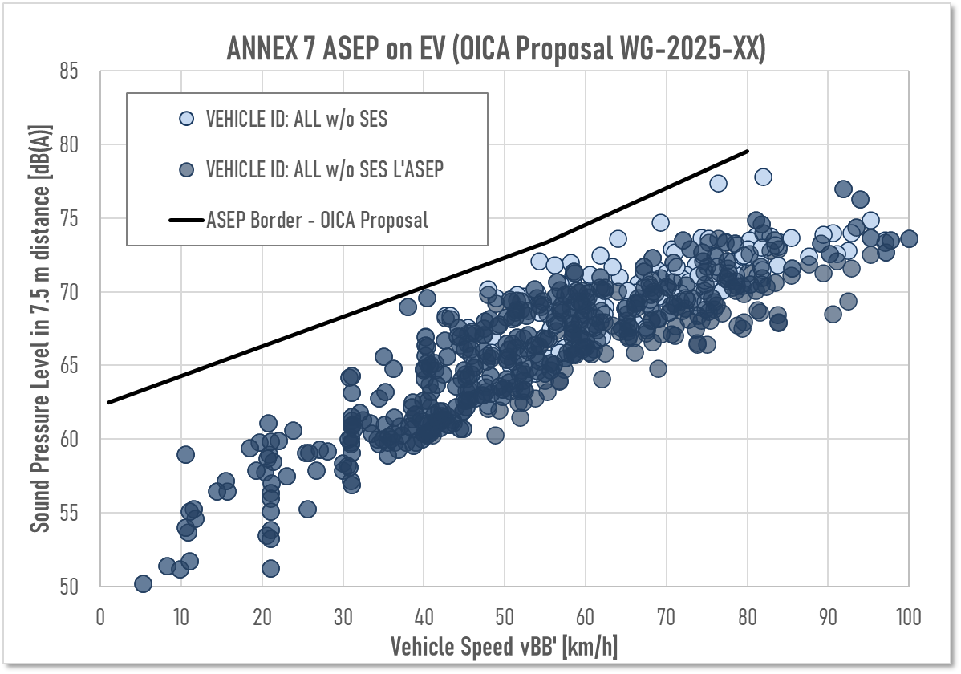

1. Explanation of graph 1:
   * The proposed limit (black line) is related to accelerated conditions of ASEP, which are the worst conditions for urban sound emission.
   * The crossing point at 0 km/h matches the maximum sound limits for stand-still condition in UN Regulation No. 138, 02 series of amendments (corrected from 2.0 m to 7.5 m due to the different methods in UN Regulation No. 138 and UN Regulation No. 51). As UN Regulation No. 51 does not provide a suitable measurement method for measuring sound in stand still condition, provisions on stationary sound cannot be included.
   * All blue dots in the graph 1 represent different driving conditions of different vehicles. The light blue dots show pass-by test runs of EVs only equipped with an AVAS and without applying ΔLASEP, while the dark blue dots show pass-by-tests of the same EVs with applying the ΔLASEP. The limit curve is designed in a way that vehicles equipped with an AVAS-only just fulfil the sound emission requirements.
   * ~~The blue dots and yellow triangles in the graph 1 represent different driving conditions of different vehicles. The yellow triangles show pass-by test runs of EVs only equipped with an AVAS, while the blue dots show pass-by-tests of EVs equipped with ESES including AVAS. The limit curve is designed in a way that vehicles equipped with an AVAS-only just fulfil the sound emission requirements.~~
2. This supplement adds sound limits for EVs based on the ASEP method in a speed range from > 0 km/h to 80 km/h. Consequently, a double regulation of sound emission using parallelly the methods of UN Regulation No. 138 for minimum safety shall be avoided, by providing a clear definition which vehicles will have to follow to maximum sound limits of UN Regulation No. 138.
3. The slope has been fixed to the maximum value, in order to achieve the maximum environmental benefit of EVs at low speeds.
4. All EVs are tested in “D” (drive mode), independent from the consideration how many effective gear ratios the vehicle has. In difference to ICE vehicles, EVs can have multiple engines and a dynamic shift of the propulsion source. This adds extended uncertainty to the sound emission of the vehicle. OICA considers the EVs falling under the same margin as vehicles tested in D with non-locked gears.
5. Graph 2: Impact of Sound emission limits based on the slope   
    assessment as proposed by the amendments provided in this   
    supplement to UN Regulation No. 51 on EVs with ESES

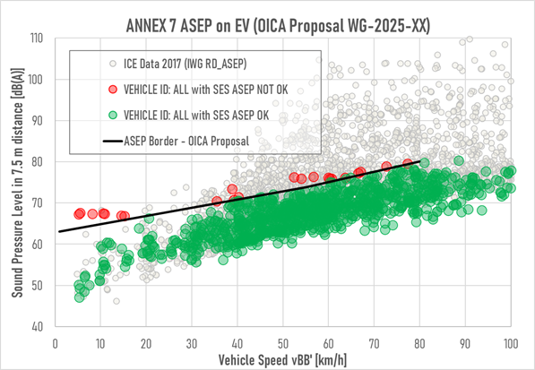

1. Explanation of the graph 2:
   * The proposed limit (black line) is related to accelerated conditions of ASEP, which are the worst conditions for urban sound emission (same as in Graph 1).
   * The green and red dots in the graph 2 represent different driving conditions of different vehicles equipped with an ESES including AVAS. The green dots show pass-by test runs of EVs meeting the proposed ASEP-requirements of this amendment, while the red dots show pass-by-tests of EVs failing the same requirements. The limit curve is designed in a way that vehicles equipped with an AVAS-only just fulfil the sound emission requirements.
   * The grey dots in background show vehicles with an ICE from the 2017 database to provide a comparison to the vehicle fleet. EVs equipped with an ESES are still the most silent vehicles on the road.
2. In addition, some EVs show that the cruise test result of Annex 3 is higher than the acceleration test result of Annex 3, which adds further uncertainty, as the anchor point based on the accelerated condition of Annex 3 is not the worst case from Annex 3, as shown in graph 3. Therefore, it is proposed to cover EVs with specified criteria under the provisions for non-locked automatic transmission.
3. Graph 3: Example for a vehicle where the measured sound under cruise condition   
   is closest to the ASEP limit curve.

40

50

60

70

80

90

100

110

0

20

40

60

80

100

**Vehicle Speed v**

**BB'**

**[km/h]**

ASEP BORDER

Accelerated pass-by tests

Constant speed pass-by tests Data constant rolling test (CRS) ONLY

**Sound Pressure Level [db(A)]**

1. Explanation of graph 3:
   * The proposed limit (black line) is related to accelerated conditions of ASEP, which are usually the worst conditions for urban sound emission (same as in Graph 1).
   * The blue and green dots in the graph 3 represent different driving conditions of one vehicle. The blue dots show pass-by test runs of this EVs accelerating, while the green dots show pass-by-tests of EVs cruising at constant speeds. This vehicle nearly fails the sound emission requirements in regard to the constant speed tests (green dots).
2. Graph 4 : Comparison of ICE-vehicles to EVs equipped with an AVAS only and EVs equipped with ESES including AVAS

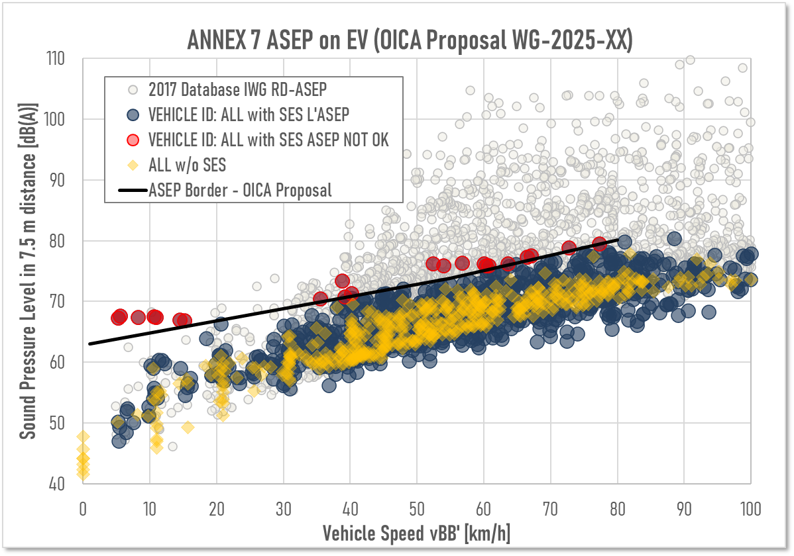

1. Explanation of graph 4:
   * The proposed limit (black line) is related to accelerated conditions of ASEP, which are usually the worst conditions for urban sound emission (same as in Graph 1).
   * The blue dots, the red dots and yellow diamonds in the graph 4 represent pass-by tests of different kinds of EVs. The blue and red dots show pass-by test runs of this EVs equipped with ESES, while the yellow diamonds show pass-by-tests of EVs only equipped with an AVAS. The red dots represent failed pass-by test runs of vehicles equipped with an ESES including AVAS.
   * The grey dots in background show vehicles with an ICE from the 2017 database to provide a comparison to the vehicle fleet. EVs equipped with an ESES are still the most silent vehicles on the road.

*Annex 9, paragraph 1. – General”*

1. As the definition of “*Exterior Sound Enhancement System (ESES)*” is introduced in paragraph 2.29. of the main body, it is proposed to align the existing term with the acronym ESES.

*Annex 9, paragraph 2.2. – Definition moved to main body*

1. This paragraph gives a definition of “*Exterior Sound Enhancement System*”. As this definition is moved to paragraph 2.29. of the main body, paragraph 2.2. of Annex 9 shall be deleted.
2. For better understanding the deleted text is shown.

*Annex 9, paragraphs 2.3. to 2.5. – Renumbered Definitions*

1. As the previous paragraph 2.2. is deleted, the following paragraphs 2.3 to 2.5. shall be renumbered accordingly.

1. **See recommendations provided by informal document GRB-68-03 as guidance for technical interpretation. The document can be found in https://unece.org/documents-reference-only-0.**
2. **The Analysis method 2 (Lurban assessment) and the Reference Sound Assessment are not applicable for these vehicles.** 
3. As applicable for the approved type of vehicle
4. As applicable for the approved type of vehicle
5. <https://wiki.unece.org/download/attachments/271089891/20241211_1__UNECE_AVAS_Geh.pdf?api=v2>

   <https://wiki.unece.org/download/attachments/271089891/20241211_114-e-perception-of-electric-vehicles-data.pdf?api=v2>