|  |  |  |  |
| --- | --- | --- | --- |
|  | United Nations | ECE/TRANS/WP.29/GRE/2025/7 | |
| _unlogo | **Economic and Social Council** | | Distr.: General  3 February 2025  Original: English |

**Economic Commission for Europe**

Inland Transport Committee

**World Forum for Harmonization of Vehicle Regulations**

**Working Party on Lighting and Light-Signalling**

**Ninety-second session**

Geneva, 22–25 April 2025

Item 6 (a) of the provisional agenda

**Installation UN Regulations:**

**UN Regulation No. 48 (Installation of Lighting and Light-Signalling Devices)**

Proposal for a Supplement to the 09 series of amendments to UN Regulation No. 48

Submitted by the experts from the International Automotive Lighting and Light-Signalling Expert Group [[1]](#footnote-2)\*

The text reproduced below was prepared by the experts from the International Automotive Lighting and Light-Signalling Expert Group (GTB) with the aim to clarify the duration of the optical indication of the answer-back signal. The proposed modifications to the current text of the UN Regulations are marked in bold for new or strikethrough for deleted characters.

I. Proposal

*Paragraph 6.27.9.*, amend to read*:*

“6.27.9. Other requirements

6.27.9.1. The answer-back signal shall be provided by approved lighting and light-signalling devices and exterior courtesy lamps where in all these cases, the maximum luminous intensity per lamp does not exceed 700 cd on or above the HH line. However, front fog lamps, rear fog lamps and stop lamps are not permitted to be used.

6.27.9.2. The answer-back signal may only be activated automatically in conjunction with the locking and unlocking of the door(s) and/or the detection of the vehicle user in proximity to the vehicle.

6.27.9.3. The lamp used for the answer-back signal may flash and/or vary in luminous intensity and/or vary in apparent surface.

6.27.9.4. The duration of the optical indication of the answer-back signal shall not exceed 3 seconds. This time is defined from the beginning to the end of the signal, irrespective of whether it contains flashes, variations of intensity or variations in apparent surface.

6.27.9.5. Compliance with the requirements of paragraphs 6.27.9.1. to 6.27.9.4. shall be demonstrated by the applicant, using test reports or other means of verification accepted by the Type Approval Authority. The information shall be indicated in item 10.9. of the communication form.”

II. Justification

1. To avoid misinterpretations with regard to the timing defined for the duration of the optical indication of the answer-back signal (3 seconds), it is necessary to clarify the beginning and the end of the optical signal in cases where the answer-back signal flashes, varies intensity or in apparent surface.

2. The proposed text to be added avoids the possibility to count only the ON time (without the OFF time) of the signal when determining that the duration of the optical indication of the answer-back signal is limited to 3 seconds.

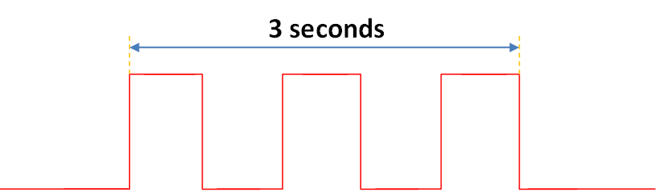

**Figure 1**

Duration of the answer-back signal

1. \* In accordance with the programme of work of the Inland Transport Committee for 2025 as outlined in proposed programme budget for 2025 (A/79/6 (Sect. 20), table 20.6), the World Forum will develop, harmonize and update UN Regulations in order to enhance the performance of vehicles. The present document is submitted in conformity with that mandate. [↑](#footnote-ref-2)