 | United Nations | ECE/TRANS/WP.29/2026/41
 | Economic and Social Council |  | Distr.: General  19 December 2025  Original: English
Economic Commission for Europe
Inland Transport Committee
World Forum for Harmonization of Vehicle Regulations
198th session
Geneva, 10–13 March 2026
Item 4.15.1 of the provisional agenda
1958 Agreement:
Proposals for amendments to the Consolidated Resolution
on the common specification of light source categories (R.E.5)

Proposal for Amendment 12 to the Consolidated Resolution on the common specification of light source categories

Submitted by the Working Party on Lighting and Light-Signalling *
The text reproduced below was adopted by the Working Party on Lighting and Light-Signalling (GRE) at its ninety-third session (ECE/TRANS/WP.29/GRE/93, paras. 10 and 11). It is based on ECE/TRANS/WP.29/GRE/2025/15 and ECE/TRANS/WP.29/GRE/2025/17. It is submitted to the World Forum for Harmonization of Vehicle Regulations (WP.29) and to the Administrative Committee (AC.1) for consideration at their March 2026 sessions.

The Status table, insert new rows 10, 11 and 12 at the bottom to read:
“
Version of the Resolution | Date* as from which the version is valid | Adopted by WP.29 |  | Clarification
Version of the Resolution | Date* as from which the version is valid | Session No. | Amendment document No. | Clarification
….
10 | 13.11.2024 | 194 | ECE/TRANS/WP.29/2024/156 | Amended detail in sheets H11_LEDr/3, H11_LEDr/6, H11_LEDr/7 to introduce Configuration-2
11 | 05.03.2025 | 195 | ECE/TRANS/WP.29/2025/40 | Introduction of new LED light source categories LW7A and LW7B
12 | 11.03.2026 | 198 | ECE/TRANS/WP.29/2026/41 | Amended details in paragraph 3.1, group 1, group 2, and group 3, concerning phase out of certain light source categories  Introduction of new LED replacement light source categories H8, H16 and HB4  Introduction of new LED light source categories LRR8A and LRR8B
* This date is the date of adoption of the amendment to the Resolution by WP.29 or the date of entering into force of an amendment to UN Regulation No. 37, 99 or 128 adopted by AC.1 as a package with the amendment to the Resolution in the same session of WP.29.”

Paragraph 3.1.,
Group 1, amend to read:
"
Group 1
Filament light source categories (or types within these categories) without general restrictions:
 | Category | Note(s) | Sheet number(s)
 | H1 | *⁶ | H1/1 to 3
 | H3 | *⁶ | H3/1 to 4
 | H4 |  | H4/1 to 5
 | H7 |  | H7/1 to 4
 | H8 |  | H8/1 to 4
 | H9 | *³ | H9/1 to 4
 | H10 |  | H10/1 to 3
 | H11 |  | H11/1 to 4
 | H13 |  | H13/1 to 4
 | H15 |  | H15/1 to 5
 | H16 |  | H16/1 to 4
 | H17 |  | H17/1 to 6
 | H18 |  | H18/1 to 4
 | H19 |  | H19/1 to 5
 | H21W | *² | H21W/1 to 2
 | HB3 |  | HB3/1 to 4
 | HB4 |  | HB4/1 to 4
 | HIR2 |  | HIR2/1 to 3
 | HS1 | *⁶ | HS1/1 to 5
 | S2 | *^{5,}*⁶ | S1/S2/1 to 2
"
Group 2, amend to read:
"
Group 2
Filament light source categories (or types within these categories) only for use in signalling lamps, cornering lamps, reversing lamps and rear registration plate lamps:
 | Category | Note(s) |  | Sheet number(s)
 | C5W |  | *⁶ | C5W/1
 | H6W |  |  | H6W/1
 | HY6W |  |  | H6W/1
 | HY21W |  |  | H21W/1 to 2
 | P13W |  |  | P13W/1 to 3
 | P21W |  | *⁶ | P21W/1 to 2
 | P21/4W |  |  | P21/4W/1 |  | (P21/5W/2 to 3)
 | P21/5W |  | *⁶ | P21/5W/1 to 3
 | P27W |  |  | P27W/1 to 2
 | P27/7W |  |  | P27/7W/1 to 3
 | PR21W |  |  | PR21W/1 |  | (P21W/2)
 | PR21/5W |  |  | PR21/5W/1 |  | (P21/5W/2 to 3)
 | PY21W |  |  | PY21W/1 | (P21W/2)
 | PY27/7W |  |  | PY27/7W/1 | (P27/7W/2 to 3)
 | R5W |  | *⁶ | R5W/1
 | R10W |  | *⁶ | R10W/1
 | RR5W |  |  | R5W/1
 | RR10W |  |  | R10W/1
 | RY10W |  | *⁶ | R10W/1
 | W2.3W |  |  | W2.3W/1
 | W3W |  | *⁶ | W3W/1
 | W5W |  | *⁶ | W5W/1
 | W10W |  | *⁶ | W10W/1
 | W15/5W |  |  | W15/5W/1 to 3
 | W16W |  |  | W16W/1
 | W21W |  |  | W21W/1 to 2
 | W21/5W |  |  | W21/5W/1 to 3
 | WR5W |  |  | W5W/1
 | WR21/5W |  |  | WR21/5W/1 | (W21/5W/2 to 3)
 | WT21W |  |  | WT21W/1 to 2
 | WT21/7W |  |  | WT21/7W/1 to 3
 | WTY21W |  |  | WT21W/1 to 2
 | WTY21/7W |  |  | WT21/7W/1 to 3
 | WY5W |  | *⁶ | W5W/1
 | WY10W |  | *⁶ | W10W/1
 | WY16W |  |  | W16W/1
 | WY21W |  |  | WY21W/1 to 2

"
Group 3, amend to read:
"
Group 3
Filament light source categories (or types within these categories) only for use in lamps as replacement parts for lamps on vehicles in use originally equipped with such lamps:
 | Category | Note(s) | Sheet number(s) | From date onwards**
 | C5W | *^{7,} *⁸ | C5W/1 | 26 July 2013
 | C21W | *⁸ | C21W/1 to 2 | 11 June 2008
 | H1 | *⁷ | H1/1 to 3 | 26 July 2013
 | H3 | *⁷ | H3/1 to 4 | 26 July 2013
 | H8B |  | H8/1 to 4 | 1 April 2028
 | H9B | *³ | H9/1 to 4 | 1 April 2028
 | H10W/1 | *⁸ | H10W/1 to 2 | 1 April 2028
 | H11B |  | H11/1 to 4 | 1 April 2028
 | H12 |  | H12/1 to 3 | 15 July 2015
 | H13A |  | H13/1 to 4 | 15 July 2015
 | H14 |  | H14/1 to 4 | 26 July 2013
 | H16B |  | H16/1 to 4 | 1 April 2028
 | H20 |  | H20/1 to 4 | 1 April 2028
 | H27W/1 |  | H27W/1 to 3 | 1 April 2028
 | H27W/2 |  | H27W/1 to 3 | 1 April 2028
 | HB3A |  | HB3/1 to 4 | 15 July 2018
 | HB4A |  | HB4/1 to 4 | 15 July 2018
 | HIR1 | *³ | HIR1/1 to 3 | 15 July 2015
 | HS1 | *⁷ | HS1/1 to 5 | 26 July 2013
 | HS2 | *⁷ | HS2/1 to 3 | 26 July 2013
 | HS2 | *⁶ | HS2/1 to 3 | 1 September 2018
 | HS5 | *⁵ | HS5/1 to 4 | 1 April 2028
 | HS5A | *⁵ | HS5A/1 to 3 | 1 September 2018
 | HS6 | *⁴ | HS6/1 to 4 | 15 July 2018
 | HY10W/1 | *⁸ | H10W/1 to 2 | 1 April 2028
 | P19W | *⁸ | P19W/1 to 3 | 28 October 2016
 | P21W | *^{7,} *⁸ | P21W/1 to 2 | 26 July 2013
 | P21/5W | *^{7,} *⁸ | P21/5W/1 to 3 | 26 July 2013
 | P24W | *⁸ | P24W/1 to 3 | 1 September 2018
 | PC16W | *⁸ | PC16W/1 to 3 | 28 October 2016
 | PCR16W | *⁸ | PC16W/1 to 3 | 28 October 2012
 | PCY16W | *⁸ | PC16W/1 to 3 | 28 October 2016
 | PR19W | *⁸ | P19W/1 to 3 | 28 October 2012
 | PR21/4W | *⁸ | PR21/4W/1;  (P21/5W/2 to 3) | 15 July 2015
 | PR24W | *⁸ | P24W/1 to 3 | 28 October 2012
 | PR27/7W | *⁸ | PR27/7W/1;  (P27/7W/2 to 3) | 15 July 2015
 | PS19W | *⁸ | P19W/1 to 3 | 1 April 2028
 | PS24W | *⁸ | P24W/1 to 3 | 1 April 2028
 | PSR19W | *⁸ | P19W/1 to 3 | 28 October 2012
 | PSR24W | *⁸ | P24W/1 to 3 | 28 October 2012
 | PSX24W | *² | P24W/1 to 3 | 1 April 2028
 | PSX26W | *² | PSX26W/1 to 3 | 1 April 2028
 | PSY19W | *⁸ | P19W/1 to 3 | 1 April 2028
 | PSY24W | *⁸ | P24W/1 to 3 | 1 April 2028
 | PW13W | *⁸ | P13W/1 to 3 | 1 April 2028
 | PW16W | *⁸ | PC16W/1 to 3 | 1 April 2028
 | PW19W | *⁸ | P19W/1 to 3 | 1 April 2028
 | PW24W | *⁸ | P24W/1 to 3 | 1 April 2028
 | PWR16W | *⁸ | PC16W/1 to 3 | 1 April 2028
 | PWR19W | *⁸ | P19W/1 to 3 | 1 April 2028
 | PWR24W | *⁸ | P24W/1 to 3 | 1 April 2028
 | PWY16W | *⁸ | PC16W/1 to 3 | 1 April 2028
 | PWY19W | *⁸ | P19W/1 to 3 | 1 April 2028
 | PWY24W | *⁸ | P24W/1 to 3 | 1 April 2028
 | PX24W | *² | P24W/1 to 3 | 1 September 2018
 | PY19W | *⁸ | P19W/1 to 3 | 28 October 2016
 | PY21/5W | *⁸ | PY21/5W/1 to 3 | 1 April 2028
 | PY24W | *⁸ | P24W/1 to 3 | 1 April 2028
 | R2 |  | R2/1 to 3 | 11 June 2008
 | R5W | *^{7,} *⁸ | R5W/1 | 26 July 2013
 | R10W | *^{7,} *⁸ | R10W/1 | 26 July 2013
 | RY10W | *^{7,} *⁸ | R10W/1 | 26 July 2013
 | S1 |  | S1/S2/1 to 2 | 11 June 2008
 | S2 | *⁷ | S1/S2/1 to 2 | 26 July 2013
 | S3 |  | S3/1 | 26 July 2013
 | T1.4W | *⁸ | T1.4W/1 | 15 July 2015
 | T4W | *^{7,} *⁸ | T4W/1 | 26 July 2013
 | T4W | *^{6,} *⁸ | T4W/1 | 1 April 2028
 | W3W | *^{7,} *⁸ | W3W/1 | 26 July 2013
 | W5W | *^{7,} *⁸ | W5W/1 | 26 July 2013
 | W10W | *^{7,} *⁸ | W10W/1 | 26 July 2013
 | WP21W | *⁸ | WP21W/1 to 2 | 1 September 2018
 | WPY21W | *⁸ | WP21W/1 to 2 | 1 September 2018
 | WY2.3W | *⁸ | WY2.3W/1 | 15 July 2015
 | WY5W | *^{7,} *⁸ | W5W/1 | 15 July 2014
 | WY10W | *^{7,} *⁸ | W10W/1 | 26 July 2013

"
Paragraph 3.3.,
Group 2, amend to read:
"
Group 2
LED light source categories only for use in signalling lamps, cornering lamps, reversing lamps and rear registration plate lamps:
 | Category |  | Sheet number(s)
 | LR1 |  | LR1/1 to 5
 | LW2 | ² | LW2/1 to 5
 | LR3A |  | Lx3/1 to 6
 | LR3B |  | Lx3/1 to 6
 | LW3A | ² | Lx3/1 to 6
 | LW3B | ² | Lx3/1 to 6
 | LY3A |  | Lx3/1 to 6
 | LY3B |  | Lx3/1 to 6
 | LR4A |  | LR4/1 to 5
 | LR4B |  | LR4/1 to 5
 | LR5A |  | Lx5/1 to 6
 | LR5B |  | Lx5/1 to 6
 | LW5A | ² | Lx5/1 to 6
 | LW5B | ² | Lx5/1 to 6
 | LY5A |  | Lx5/1 to 6
 | LY5B |  | Lx5/1 to 6
 | LR6A |  | Lx6/1 to 6
 | LR6B |  | Lx6/1 to 6
 | LW6A | ² | Lx6/1 to 6
 | LW6B | ² | Lx6/1 to 6
 | LY6A |  | Lx6/1 to 6
 | LY6B |  | Lx6/1 to 6
 | LW7A | ² | Lx7/1 to 6
 | LW7B | ² | Lx7/1 to 6
 | LRR8A |  | LRR8/1 to 6
 | LRR8B |  | LRR8/1 to 6
"
Group 5, amend to read:
“
Group 5
LED replacement light source categories^{3, 4} only for use in lamps approved with filament light source(s) with the same category designation
Category | Sheet number(s)
C5W | C5W_LEDr/1 to 4
H8 | H8_LEDr/1 to 7
H11 | H11_LEDr/1 to 7
H16 | H16_LEDr/1 to 7
HB4 | HB4_LEDr/1 to 7
”
Annex 3, sheets for LED light sources, amend the listing to read:
“List of sheets for LED light sources and their sequence in this annex:
Sheet number(s)
C5W/LED/1 to 4
C5W_LEDr/1 to 4
H8_LEDr/1 to 7
H11/LED/1 to 7
H11_LEDr/1 to 7
H16_LEDr/1 to 7
HB4_LEDr/1 to 7
L1/1 to 5
LR1/1 to 5
LW2/1 to 5
Lx3/1 to 6
LR4/1 to 5
Lx5/1 to 6
Lx6/1 to 6
Lx7/1 to 6
LRR8/1 to 6
PY21W/LED/1 to 4
R5W/LED/1 to 4
W5W/LED/1 to 4
”
Annex 3,
After sheet C5W_LEDr/4, insert new sheets H8_LEDr/1 to 7,
After sheet H11_LEDr/7, insert new sheets H16_LEDr/1 to 7 and HB4_LEDr/1 to 7, and
After sheet Lx7/6, insert new sheets LRR8/1 to 6, to read:
(see following pages; one page per sheet)

Category H8 Sheet H8_LEDr/1
The drawings are intended only to illustrate the essential dimensions (in mm) of the LED light source.
Figure 1
Main drawings

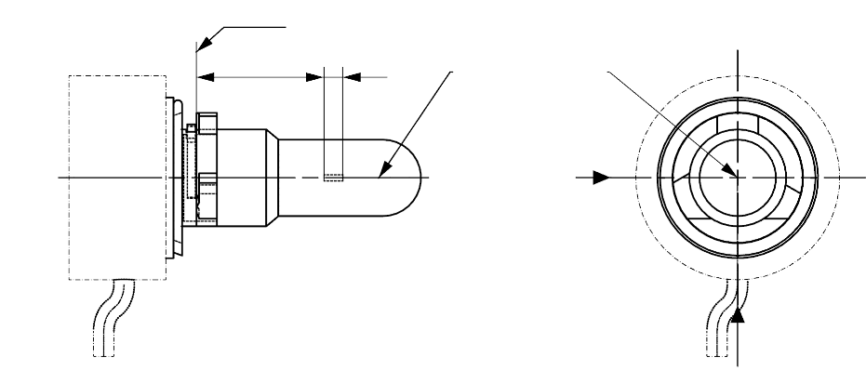
T_{cap} ^{5/}
View C
View A
Reference plane ^{1/}
Reference axis ^{2/}
A
B
e
f
^{4/}

Figure 2
Maximum LED light source outline ^{3/}
35
∅15.0
25.0
4
44.0
∅19.0
∅25.0
∅ 50
50°
Reference plane
Reference axis

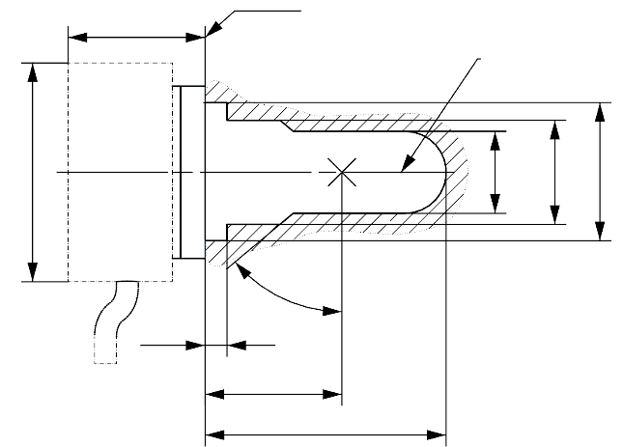

^{1/} The reference plane is the plane formed by the underside of the bevelled lead-in flange of the cap.
^{2/} The reference axis is perpendicular to the reference plane and passing through the centre of the 19 mm cap diameter.
^{3/} The LED light source shall not exceed the envelope as indicated in Figure 2.
^{4/} The light source shall function in either voltage polarity.
^{5/} Measurement point for cap temperature T_{cap}

Category H8 Sheet H8_LEDr/2
Table 1
Essential electrical and photometrical characteristics of the LED light source

Dimensions in mm |  |  | LED light sources of normal production
e ^{2/} |  |  | 25.0 nom.
f ^{2/} |  |  | 3.7 nom.
Contrast ^{4/} |  |  | 100 min.
Elevated ambient air temperature ^{3/} |  |  | 60°C
Cap H8 PGJ19-1 ^{6/} in accordance with IEC Publication 60061 (sheet 7004-110-3)
Electrical and photometric characteristics ^{9/}
Rated values |  | Volts | 12
 |  | Watts | 18 ^{8/}
Test voltage (DC) |  | Volts | 13.2
Objective values | Power | Watts | 18 min. ^{7/}  43 max. ^{8/}
Objective values | Cap temperature T_{cap} | °C | 100 max. ^{7/}
Objective values | Electrical current | mA | 1300 min. ^{7/}  (at 12-14 V DC)
Objective values | Luminous flux ^{1/ 3/} | lm | 800 ± 15%
Objective values | Luminous flux deviation ^{5/}  (voltage range limits) | lm | ±10% (at 12V)  ±10% (at 14V)

^{1/} The light emitted shall be white or selective yellow without a correlated colour temperature restriction.
^{2/} To be checked by means of a "box system", sheet H8 LEDr/3
^{3/} The luminous flux measured at the elevated ambient air temperature shall be at least 75% of the objective luminous flux (both measured at test voltage)
^{4/} The contrast is the proportion of luminous flux originating from two different areas, see details in sheet H8_LEDr/3
^{5/} The maximum luminous flux deviation at the tolerance limits is calculated by using the measured flux at test voltage as reference. The luminous flux behaviour shall be substantially uniform within the specified voltage range.
^{6/} The maximum specifications of parameters G and K are excluded, but the maximum outline dimensions in Figure 2 apply
^{7/} Not applicable for high-efficiency type
^{8/} For high-efficiency type 12W rated value and 18W max. objective value applies
^{9/} In case of LED light source failure (no light emitted) the max. electrical current draw, when operated between 12V and 14V, shall be less than 100 mA (open circuit condition)

Category H8 Sheet H8_LEDr/3
Screen projection requirements
The following test is intended to define the requirements for the apparent light emitting area of the LED light source and to determine whether the light emitting area is correctly positioned relative to the reference axis and reference plane in order to check compliance with the requirements.
The position of the light emitting area is checked by a box system defined in Figure 3 when operated at test voltage, which shows the projections when viewing from A and –A (see sheet H8_LEDr/1, Figure 1), i.e. along the C-planes C₉₀ and C₂₇₀ (as defined in Figure 5). The distance z between the surfaces of the opposite light emitting areas shall not exceed 2.9 mm.
The proportion of the total luminous flux emitted into these viewing directions from the area(s) as defined in Figure 3:
• Total box area: (A+B+C) / E shall be not less than 90%
• Area A: A / (A+B+C) shall be not more than 14%
• Areas B₁, B₂ and B₃: B₁/B, B₂/B, B₃/B shall each be not less than 15%
• Area B: B / (A+B+C) shall be not less than 65 %
• Area C: C / (A+B+C) shall be not more than 27%
Figure 3
Box definition of the light emitting area (dimensions given in Table 2)
c1
x1
x2
c2
b1
b2
y1
y1
e
a1/2
a2
E
B₁
B₂
B₃
C
B
A
Reference axis
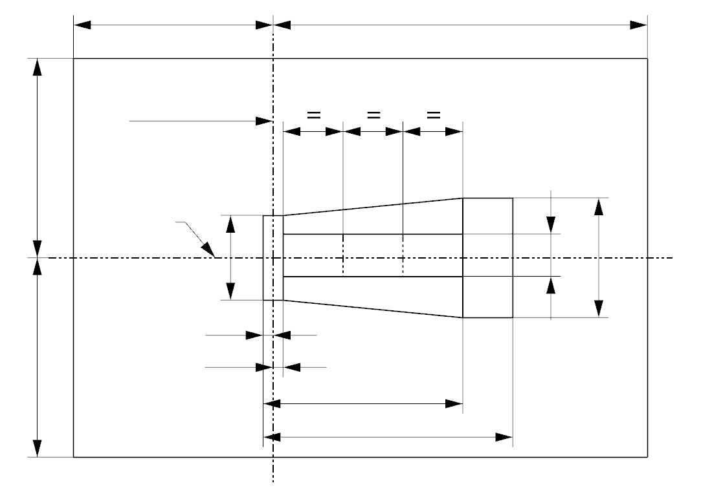
a1
The contrast is checked by a box system defined in Figure 4 when operated at test voltage, which shows the projections when viewing from A and –A (see sheet H8_LEDr/1, Figure 1), i.e. along the C-planes C₉₀ and C₂₇₀ (as defined in Figure 5).

Category H8 Sheet H8_LEDr/4
The contrast is the proportion of the total luminous flux values emitted into these viewing directions from the corresponding areas (A+B+C) and D. The value of the contrast (A+B+C) / D shall be within the limits given in Table 1 (see Figure 4 for the definition of the area D).
Figure 4
Box definition of the area D (dimensions given in Table 2)

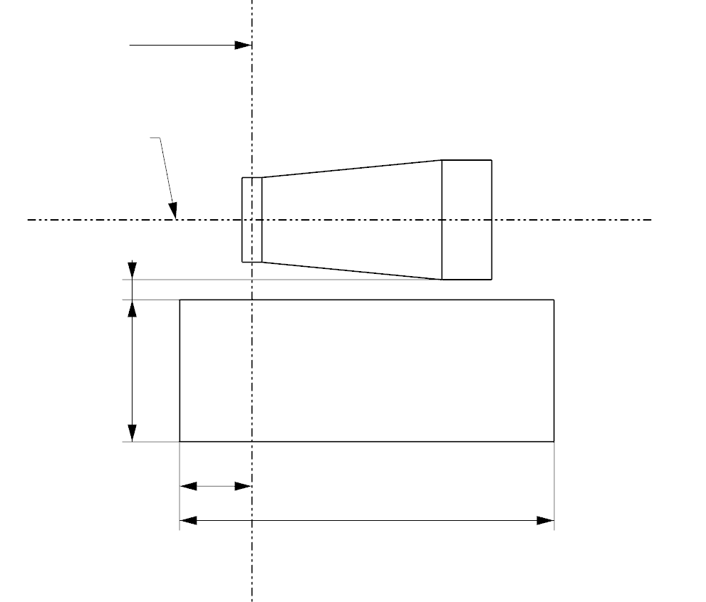
g2
g3
d
g1
A
D
C
B
e
Reference axis

Table 2
Dimensions of the box definitions in Figure 3 and Figure 4
All views  (as specified above) | Dimensions in mm | All views  (as specified above) | Dimensions in mm
a1 | 1.7 | x1 | 25
a2 | 1.9 | x2 | 19
b1 | 0.25 | y1 | 12.5
b2 | 0.25 | g1 | 2.85
c1 | 4.6 | g2 | 6.9
c2 | 3.5 | g3 | 1.4
d | 0.4

Category H8 Sheet H8_LEDr/5
Normalized luminous intensity distribution
The following test is intended to determine the normalized luminous intensity distribution of the light source in the C-planes as described in Figure 5 when operated at test voltage. The intersection of the reference axis and the plane parallel to the reference plane at distance e = 25.0 mm is used as the coordinate system origin.
The light source is mounted on a flat plate with the corresponding holder features. The plate is fixed to the goniometer table by a bracket, so that the reference axis of the light source lines up with one of the rotating axis of the goniometer. The corresponding measurement set-up is described in Figure 5.
Luminous intensity data is recorded with a standard photo-goniometer. The measurement distance should be chosen appropriately in order to make sure that the detector is located in the far field of the light distribution.
The measurements shall be performed in C-planes for which the line of intersection coincides with the reference axis of the light source. The test points for each plane and polar angles γ are specified in Table 3.
The measured luminous intensity values, normalised to the measured luminous flux of the individual light source under test, shall be converted to normalised luminous intensity values of a 1000 lm light source. These data shall comply with the limits as defined in Table 3.
Figure 5
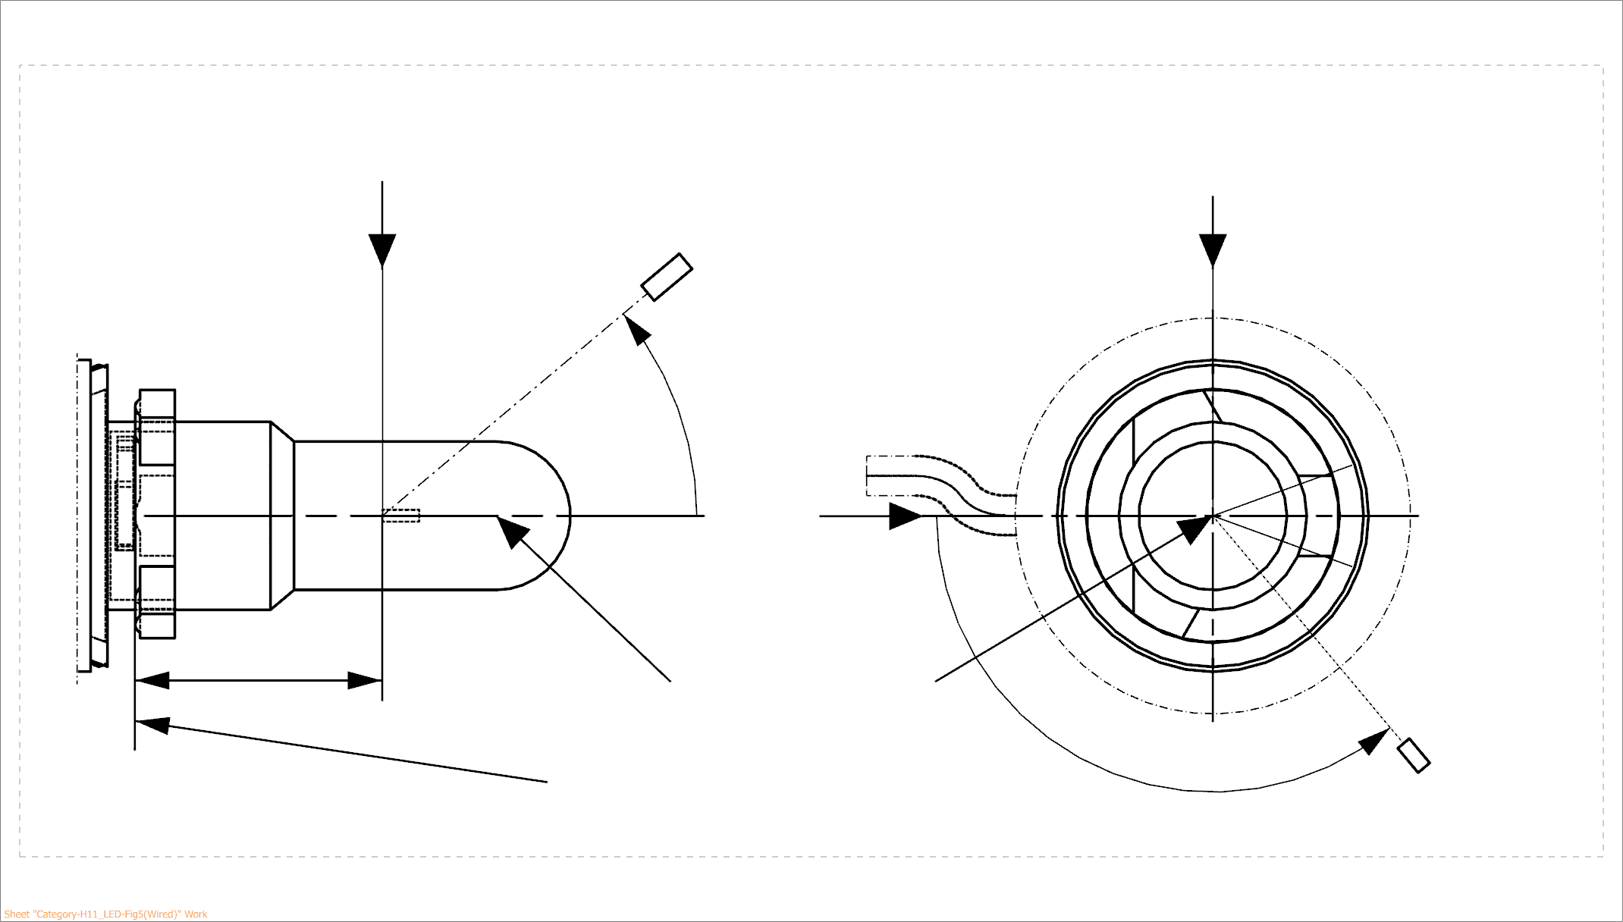
Setup to measure the luminous intensity distribution and the definition of C-Planes and angle γ
25,0
View from B
View from C
Reference plane
Reference axis
B
A
C = 270°
C = 90°
C = 180°
C
C = 0°
γ
A
Photo-Detector of Goniometer

C-planes: see CIE publication 70-1987, "The measurement of absolute intensity distributions".

Category H8 Sheet H8_LEDr/6

Table 3 – Part 1

Test point values of normalized intensity

LED light source of normal production
 | Minimum intensity (cd/klm) | Maximum intensity (cd/klm)
γ | C₀, C₉₀, C₁₈₀, C₂₇₀ | C₀, C₉₀, C₁₈₀, C₂₇₀
0° | n/a | 10
10° | n/a | 10
20° | n/a | 10
30° | n/a | 10
The light pattern as described in Table 3 – part 1 shall be substantially uniform, i.e. in between two adjacent grid points the relative luminous intensity requirement is calculated by linear interpolation using the two adjacent grid points. In case of doubt this may be checked in addition to verification of the grid points given in Table 3 – part 1.

Table 3 – Part 2

Test point values of normalized intensity

 | LED light source of normal production
 | Minimum intensity (cd/klm) | Maximum intensity (cd/klm)
γ | C₉₀, C₂₇₀ | C₉₀, C₂₇₀
50° | 100 | 160
60° | 115 | 175
70° | 125 | 185
80° | 130 | 190
90° | 130 | 195
100° | 130 | 190
110° | 125 | 185
120° | 115 | 175
130° | 100 | 160
140° | 80 | 145

The light pattern as described in Table 3 – part 2 (excluding the sections between C₉₀ and C₂₇₀ and between C₂₇₀ and C₉₀) shall be substantially uniform, i.e. in between two adjacent grid points the relative luminous intensity requirement is calculated by linear interpolation using the two adjacent grid points. In case of doubt this may be checked in addition to verification of the grid points given in Table 3 – part 2.

Category H8 Sheet H8_LEDr/7

Table 3 – Part 3

Test point values of normalized intensity

 | LED light source of normal production
 | Minimum intensity (cd/klm) | Maximum intensity (cd/klm)
C-plane | γ = 90° | γ = 90°
C₀ | n.a. | n.a.
C₃₀ | 50 | 130
C₆₀ | 110 | 175
C₉₀ | 130 | 195
C₁₂₀ | 110 | 175
C₁₅₀ | 50 | 130
C₁₈₀ | n.a. | n.a.
C₂₁₀ | 50 | 130
C₂₄₀ | 110 | 175
C₂₇₀ | 130 | 195
C₃₀₀ | 110 | 175
C₃₃₀ | 50 | 130
C₃₆₀ (= C₀₎ | n.a. | n.a.

The light pattern as described in Table 3 – part 3 (excluding the sections between C₁₅₀ and C₂₁₀ and between C₃₃₀ and C₃₀) shall be substantially uniform, i.e. in between two adjacent grid points the relative luminous intensity requirement is calculated by linear interpolation using the two adjacent grid points. In case of doubt this may be checked in addition to verification of the grid points given in Table 3 – part 3.

Category H16 Sheet H16_LEDr/1
The drawings are intended only to illustrate the essential dimensions (in mm) of the LED light source.
Figure 1
Main drawings

T_{cap} ^{5/}
View C
View A
Reference plane ^{1/}
Reference axis ^{2/}
A
B
e
f
^{4/}

Figure 2
Maximum LED light source outline ^{3/}
35
∅15.0
25.0
4
44.0
∅19.0
∅25.0
∅ 50
50°
Reference plane
Reference axis

^{1/} The reference plane is the plane formed by the underside of the bevelled lead-in flange of the cap.
^{2/} The reference axis is perpendicular to the reference plane and passing through the centre of the 19 mm cap diameter.
^{3/} The LED light source shall not exceed the envelope as indicated in Figure 2.
^{4/} The light source shall function in either voltage polarity.
^{5/} Measurement point for cap temperature T_{cap}

Category H16 Sheet H16_LEDr/2
Table 1
Essential electrical and photometrical characteristics of the LED light source

Dimensions in mm |  |  | LED light sources of normal production
e ^{2/} |  |  | 25.0 nom.
f ^{2/} |  |  | 3.2 nom.
Contrast ^{4/} |  |  | 100 min.
Elevated ambient air temperature ^{3/} |  |  | 60°C
Cap H16 PGJ19-3 ^{6/} in accordance with IEC Publication 60061 (sheet 7004-110-3)
Electrical and photometric characteristics ^{9/}
Rated values |  | Volts | 12
 |  | Watts | 10 ^{8/}
Test voltage (DC) |  | Volts | 13.2
Objective values | Power | Watts | 10 min. ^{7/}  26 max. ^{8/}
Objective values | Cap temperature T_{cap} | °C | 100 max. ^{7/}
Objective values | Electrical current | mA | 750 min. ^{7/}  (at 12-14 V DC)
Objective values | Luminous flux ^{1/ 3/} | lm | 500 + 10% / -15%
Objective values | Luminous flux deviation ^{5/}  (voltage range limits) | lm | ±10% (at 12V)  ±10% (at 14V)

^{1/} The light emitted shall be white or selective yellow without a correlated colour temperature restriction.
^{2/} To be checked by means of a "box system", sheet H16_LEDr/3
^{3/} The luminous flux measured at the elevated ambient air temperature shall be at least 75% of the objective luminous flux (both measured at test voltage)
^{4/} The contrast is the proportion of luminous flux originating from two different areas, see details in sheet H16_LEDr/3
^{5/} The maximum luminous flux deviation at the tolerance limits is calculated by using the measured flux at test voltage as reference. The luminous flux behaviour shall be substantially uniform within the specified voltage range.
^{6/} The maximum specifications of parameters G and K are excluded, but the maximum outline dimensions in Figure 2 apply
^{7/} Not applicable for high-efficiency type
^{8/} For high-efficiency type 8W rated value and 10W max. objective value applies
^{9/} In case of LED light source failure (no light emitted) the max. electrical current draw, when operated between 12V and 14V, shall be less than 100 mA (open circuit condition)

Category H16 Sheet H16_LEDr/3
Screen projection requirements
The following test is intended to define the requirements for the apparent light emitting area of the LED light source and to determine whether the light emitting area is correctly positioned relative to the reference axis and reference plane in order to check compliance with the requirements.
The position of the light emitting area is checked by a box system defined in Figure 3 when operated at test voltage, which shows the projections when viewing from A and –A (see sheet H16_LEDr/1, Figure 1), i.e. along the C-planes C₉₀ and C₂₇₀ (as defined in Figure 5). The distance z between the surfaces of the opposite light emitting areas shall not exceed 2.9 mm.
The proportion of the total luminous flux emitted into these viewing directions from the area(s) as defined in Figure 3:
• Total box area: (A+B+C) / E shall be not less than 90%
• Area A: A / (A+B+C) shall be not more than 19%
• Areas B₁, B₂ and B₃: B₁/B, B₂/B, B₃/B shall each be not less than 15%
• Area B: B / (A+B+C) shall be not less than 58 %
• Area C: C / (A+B+C) shall be not more than 32%
Figure 3
Box definition of the light emitting area (dimensions given in Table 2)
c1
x1
x2
c2
b1
b2
y1
y1
e
a1/2
a2
E
B₁
B₂
B₃
C
B
A
Reference axis
a1
The contrast is checked by a box system defined in Figure 4 when operated at test voltage, which shows the projections when viewing from A and –A (see sheet H16_LEDr/1, Figure 1), i.e. along the C-planes C₉₀ and C₂₇₀ (as defined in Figure 5).

Category H16 Sheet H16_LEDr/4
The contrast is the proportion of the total luminous flux values emitted into these viewing directions from the corresponding areas (A+B+C) and D. The value of the contrast (A+B+C) / D shall be within the limits given in Table 1 (see Figure 4 for the definition of the area D).
Figure 4
Box definition of the area D (dimensions given in Table 2)

g2
g3
d
g1
A
D
C
B
e
Reference axis

Table 2
Dimensions of the box definitions in Figure 3 and Figure 4
All views  (as specified above) | Dimensions in mm | All views  (as specified above) | Dimensions in mm
a1 | 1.6 | x1 | 25
a2 | 1.8 | x2 | 19
b1 | 0.25 | y1 | 12.5
b2 | 0.25 | g1 | 2.7
c1 | 3.6 | g2 | 5.4
c2 | 2.6 | g3 | 1.15
d | 0.4

Category H16 Sheet H16_LEDr/5
Normalized luminous intensity distribution
The following test is intended to determine the normalized luminous intensity distribution of the light source in the C-planes as described in Figure 5 when operated at test voltage. The intersection of the reference axis and the plane parallel to the reference plane at distance e = 25.0 mm is used as the coordinate system origin.
The light source is mounted on a flat plate with the corresponding holder features. The plate is fixed to the goniometer table by a bracket, so that the reference axis of the light source lines up with one of the rotating axis of the goniometer. The corresponding measurement set-up is described in Figure 5.
Luminous intensity data is recorded with a standard photo-goniometer. The measurement distance should be chosen appropriately in order to make sure that the detector is located in the far field of the light distribution.
The measurements shall be performed in C-planes for which the line of intersection coincides with the reference axis of the light source. The test points for each plane and polar angles γ are specified in Table 3.
The measured luminous intensity values, normalised to the measured luminous flux of the individual light source under test, shall be converted to normalised luminous intensity values of a 1000 lm light source. These data shall comply with the limits as defined in Table 3.
Figure 5
Setup to measure the luminous intensity distribution and the definition of C-Planes and angle γ
25,0
View B
View C
Reference plane
Reference axis
B
A
C = 270°
C = 90°
C = 180°
C
C = 0°
γ
A
Photo-Detector of Goniometer

C-planes: see CIE publication 70-1987, "The measurement of absolute intensity distributions".

Category H16 Sheet H16_LEDr/6

Table 3 – Part 1

Test point values of normalized intensity

LED light source of normal production
 | Minimum intensity (cd/klm) | Maximum intensity (cd/klm)
γ | C₀, C₉₀, C₁₈₀, C₂₇₀ | C₀, C₉₀, C₁₈₀, C₂₇₀
0° | n/a | 10
10° | n/a | 10
20° | n/a | 10
30° | n/a | 10
The light pattern as described in Table 3 – part 1 shall be substantially uniform, i.e. in between two adjacent grid points the relative luminous intensity requirement is calculated by linear interpolation using the two adjacent grid points. In case of doubt this may be checked in addition to verification of the grid points given in Table 3 – part 1.

Table 3 – Part 2

Test point values of normalized intensity

 | LED light source of normal production
 | Minimum intensity (cd/klm) | Maximum intensity (cd/klm)
γ | C₉₀, C₂₇₀ | C₉₀, C₂₇₀
50° | 100 | 160
60° | 115 | 175
70° | 125 | 185
80° | 130 | 190
90° | 130 | 195
100° | 130 | 190
110° | 125 | 185
120° | 115 | 175
130° | 100 | 160
140° | 80 | 145
The light pattern as described in Table 3 – part 2 (excluding the sections between C₉₀ and C₂₇₀ and between C₂₇₀ and C₉₀) shall be substantially uniform, i.e. in between two adjacent grid points the relative luminous intensity requirement is calculated by linear interpolation using the two adjacent grid points. In case of doubt this may be checked in addition to verification of the grid points given in Table 3 – part 2.

Category H16 Sheet H16_LEDr/7

Table 3 – Part 3

Test point values of normalized intensity

 | LED light source of normal production
 | Minimum intensity (cd/klm) | Maximum intensity (cd/klm)
C-plane | γ = 90° | γ = 90°
C₀ | n.a. | n.a.
C₃₀ | 50 | 130
C₆₀ | 110 | 175
C₉₀ | 130 | 195
C₁₂₀ | 110 | 175
C₁₅₀ | 50 | 130
C₁₈₀ | n.a. | n.a.
C₂₁₀ | 50 | 130
C₂₄₀ | 110 | 175
C₂₇₀ | 130 | 195
C₃₀₀ | 110 | 175
C₃₃₀ | 50 | 130
C₃₆₀ (= C₀₎ | n.a. | n.a.
The light pattern as described in Table 3 – part 3 (excluding the sections between C₁₅₀ and C₂₁₀ and between C₃₃₀ and C₃₀) shall be substantially uniform, i.e. in between two adjacent grid points the relative luminous intensity requirement is calculated by linear interpolation using the two adjacent grid points. In case of doubt this may be checked in addition to verification of the grid points given in Table 3 – part 3.

Category HB4 Sheet HB4_LEDr/1
The drawings are intended only to illustrate the essential dimensions (in mm) of the LED light source.
Figure 1
Main drawings
Reference diameter
Reference plane ^{1/}
Reference axis ^{2/}
T_{cap} ^{6/}
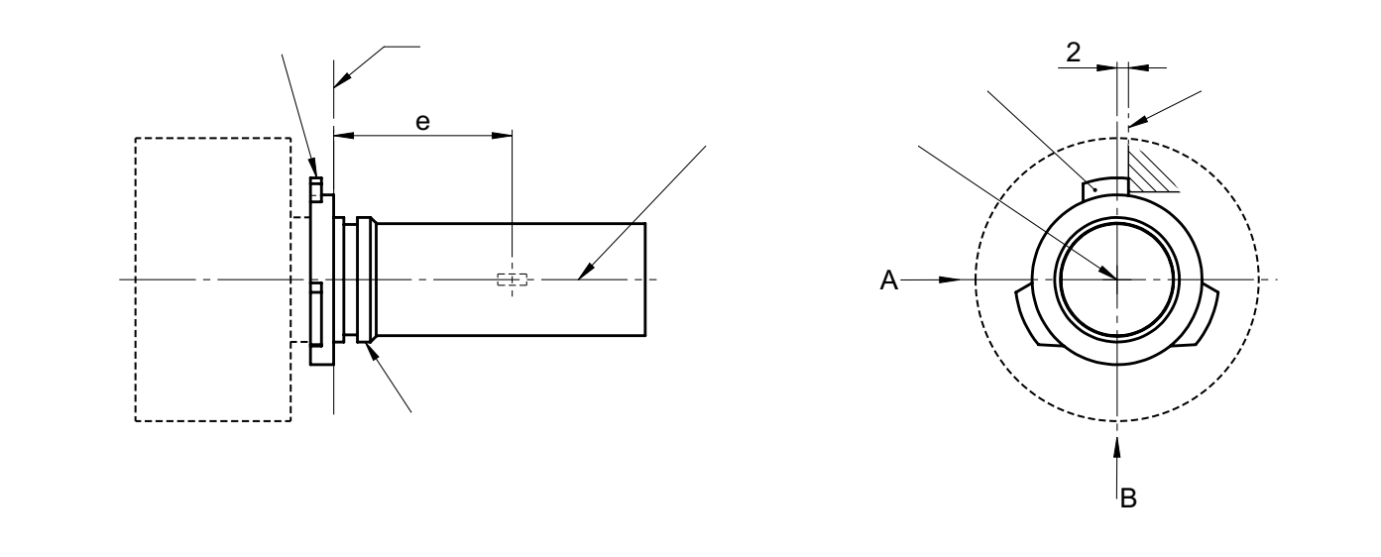
^{5/}
View A
View C
Reference lug

Figure 2
Maximum LED light source outline ^{3/}
Reference plane ^{1/}
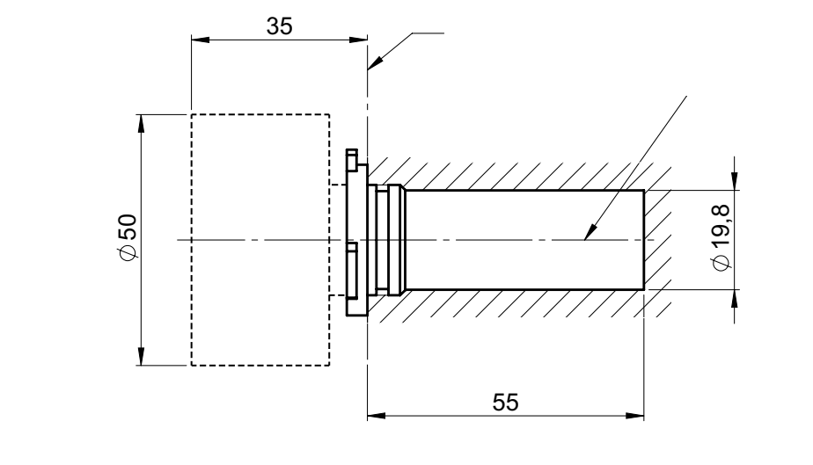
Reference axis ^{2/}

^{1/} The reference plane is the plane defined by the meeting points of cap-holder fit.
^{2/} The reference axis is perpendicular to the reference plane and concentric with the reference diameter of the cap.
^{3/} The LED light source shall not exceed the envelope as indicated in Figure 2.
^{4/} The light source shall function in either voltage polarity.
_{5/} The LED light source shall be rotated in the measuring holder until the reference lug contacts the plane of the holder
^{6/} Measurement point for cap temperature T_{cap}

Category HB4 Sheet HB4_LEDr/2
Table 1
Essential electrical and photometrical characteristics of the LED light source

Dimensions in mm ^{9/} |  |  | LED light sources of normal production
e ^{2/} |  |  | 31.5 nom.
f ^{2/} |  |  | 5.1 nom.
Contrast ^{4/} |  |  | 100 min.
Elevated ambient air temperature ^{3/} |  |  | 60°C
Cap HB4 P22d ^{6/} in accordance with IEC Publication 60061 (sheet 7004-32-2)
Electrical and photometric characteristics ^{10/}
Rated values |  | Volts | 12
 |  | Watts | 25 ^{8/}
Test voltage (DC) |  | Volts | 13.2
Objective values | Power | Watts | 25 min. ^{7/}  62 max. ^{8/}
Objective values | Cap temperature T_{cap} | °C | 100 max. ^{7/}
Objective values | Electrical current | mA | 1900 min. ^{7/}  (at 12-14 V DC)
Objective values | Luminous flux ^{1/ 3/} | lm | 1095 ± 15%
Objective values | Luminous flux deviation ^{5/}  (voltage range limits) | lm | ±10% (at 12V)  ±10% (at 14V)

^{1/} The light emitted shall be white or selective yellow without a correlated colour temperature restriction.
^{2/} To be checked by means of a "box system", sheet HB4_LEDr/3
^{3/} The luminous flux measured at the elevated ambient air temperature shall be at least 75% of the objective luminous flux (both measured at test voltage)
^{4/} The contrast is the proportion of luminous flux originating from two different areas, see details in sheet HB4_LEDr/3
^{5/} The maximum luminous flux deviation at the tolerance limits is calculated by using the measured flux at test voltage as reference. The luminous flux behaviour shall be substantially uniform within the specified voltage range.
^{6/} The maximum specifications of parameter AC, AE and AO are excluded, but the maximum outline dimensions in Figure 2 apply
^{7/} Not applicable for high-efficiency type
^{8/} For high-efficiency type 16W rated value and 25W max. objective value applies
^{9/} Dimensions shall be checked with O-ring removed
^{10/} In case of LED light source failure (no light emitted) the max. electrical current draw, when operated between 12V and 14V, shall be less than 100 mA (open circuit condition)

Category HB4 Sheet HB4_LEDr/3
Screen projection requirements
The following test is intended to define the requirements for the apparent light emitting area of the LED light source and to determine whether the light emitting area is correctly positioned relative to the reference axis and reference plane in order to check compliance with the requirements.
The position of the light emitting area is checked by a box system defined in Figure 3 when operated at test voltage, which shows the projections when viewing from A and –A (see sheet HB4_LEDr/1, Figure 1), i.e. along the C-planes C₉₀ and C₂₇₀ (as defined in Figure 5). The distance z between the surfaces of the opposite light emitting areas shall not exceed 2.9 mm.
The proportion of the total luminous flux emitted into these viewing directions from the area(s) as defined in Figure 3:
• Total box area: (A+B+C) / E shall be not less than 90%
• Area B: B / (A+B+C) shall be not less than 73%
• Areas B₁, B₂ and B₃: B₁/B, B₂/B, B₃/B shall each be not less than 15%
• Area A: A / (A+B+C) shall be not more than 14 %
• Area C: C / (A+B+C) shall be not more than 17%
Figure 3
Box definition of the light emitting area (dimensions given in Table 2)
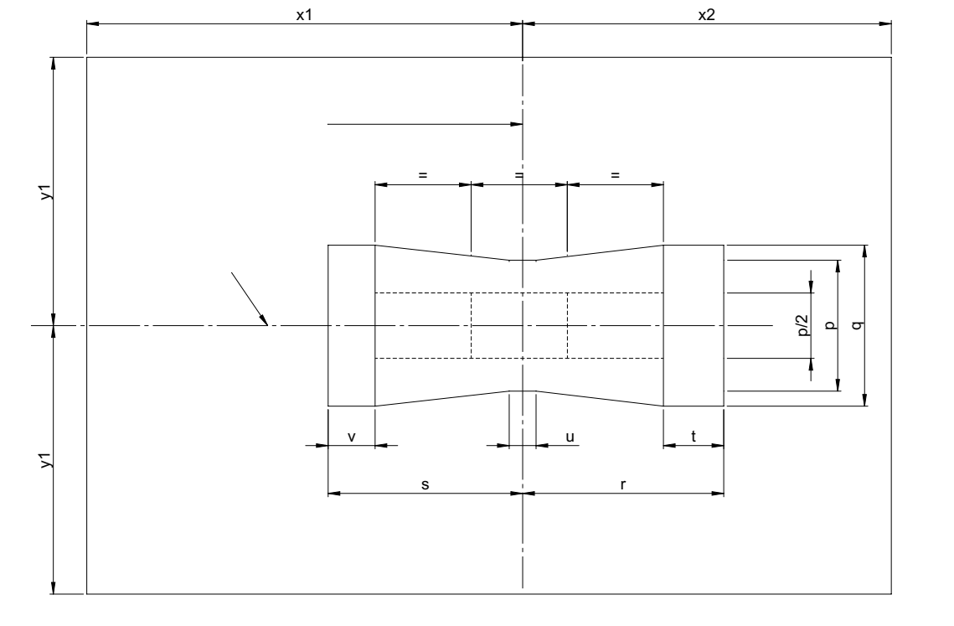
e
E
B₃
B₂
B₁
C
A
B
Reference axis

The contrast is checked by a box system defined in Figure 4 when operated at test voltage, which shows the projections when viewing from A and –A (see sheet HB4_LEDr/1, Figure 1), i.e. along the C-planes C₉₀ and C₂₇₀ (as defined in Figure 5).

Category HB4 Sheet HB4_LEDr/4
The contrast is the proportion of the total luminous flux values emitted into these viewing directions from the corresponding areas (A+B+C) and D. The value of the contrast (A+B+C) / D shall be within the limits given in Table 1 (see Figure 4 for the definition of the area D).
Figure 4
Box definition of the area D (dimensions given in Table 2)

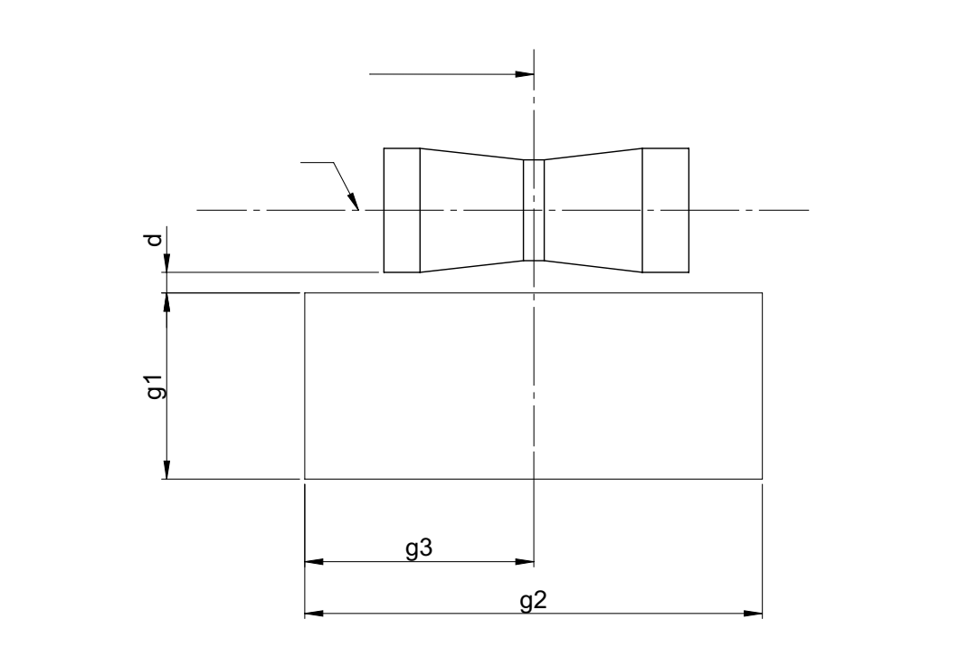
Reference axis
e
C
A
B
D

Table 2
Dimensions of the box definitions in Figure 3 and Figure 4
All views  (as specified above) | Dimensions in mm | All views  (as specified above) | Dimensions in mm
p | 1.95 | x1 | 31.5
q | 2.4 | x2 | 23.5
u | 0.4 | y1 | 9.9
v | 0.7 | g1 | 3.6
t | 0.9 | g2 | 8.85
r | 3.0 | g3 | 4.43
s | 2.9 | d | 0.4

Category HB4 Sheet HB4_LEDr/5
Normalized luminous intensity distribution
The following test is intended to determine the normalized luminous intensity distribution of the light source in the C-planes as described in Figure 5 when operated at test voltage. The intersection of the reference axis and the plane parallel to the reference plane at distance e = 31.5 mm is used as the coordinate system origin.
The light source is mounted on a flat plate with the corresponding holder features. The plate is fixed to the goniometer table by a bracket, so that the reference axis of the light source lines up with one of the rotating axis of the goniometer. The corresponding measurement set-up is described in Figure 5.
Luminous intensity data is recorded with a standard photo-goniometer. The measurement distance should be chosen appropriately in order to make sure that the detector is located in the far field of the light distribution.
The measurements shall be performed in C-planes for which the line of intersection coincides with the reference axis of the light source. The test points for each plane and polar angles γ are specified in Table 3.
The measured luminous intensity values, normalised to the measured luminous flux of the individual light source under test, shall be converted to normalised luminous intensity values of a 1000 lm light source. These data shall comply with the limits as defined in Table 3.
Figure 5
Setup to measure the luminous intensity distribution and the definition of C-Planes and angle γ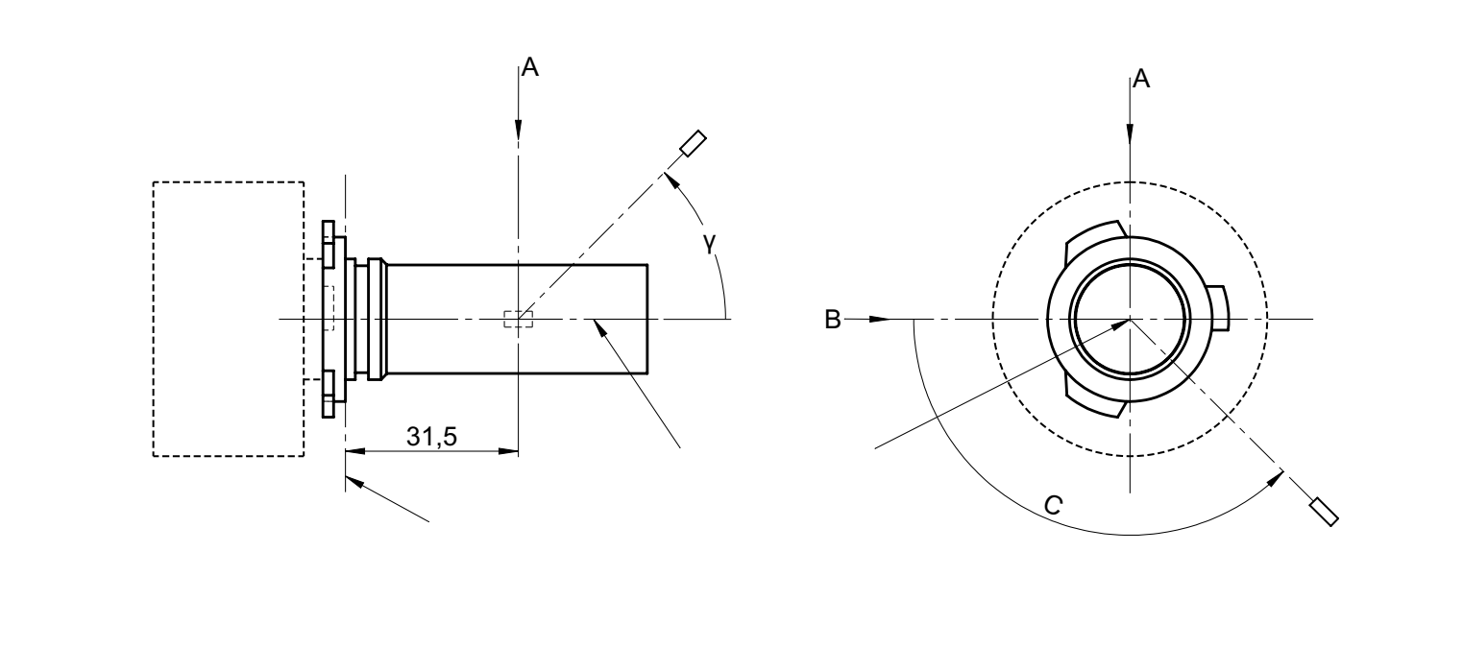
View B
View C
Photo-Detector of Goniometer
Reference plane
Reference axis
C = 0°
C = 180°
C = 270°
C = 90°

C-planes: see CIE publication 70-1987, "The measurement of absolute intensity distributions".

Category HB4 Sheet HB4_LEDr/6

Table 3 – Part 1

Test point values of normalized intensity

LED light source of normal production
 | Minimum intensity (cd/klm) | Maximum intensity (cd/klm)
γ | C₀, C₉₀, C₁₈₀, C₂₇₀ | C₀, C₉₀, C₁₈₀, C₂₇₀
0° | n/a | 10
10° | n/a | 10
20° | n/a | 10
30° | n/a | 10
The light pattern as described in Table 3 – part 1 shall be substantially uniform, i.e. in between two adjacent grid points the relative luminous intensity requirement is calculated by linear interpolation using the two adjacent grid points. In case of doubt this may be checked in addition to verification of the grid points given in Table 3 – part 1.

Table 3 – Part 2

Test point values of normalized intensity

 | LED light source of normal production
 | Minimum intensity (cd/klm) | Maximum intensity (cd/klm)
γ | C₉₀, C₂₇₀ | C₉₀, C₂₇₀
50° | 100 | 160
60° | 115 | 175
70° | 125 | 185
80° | 130 | 190
90° | 130 | 195
100° | 130 | 190
110° | 125 | 185
120° | 115 | 175
130° | 100 | 160
140° | 80 | 145
The light pattern as described in Table 3 – part 2 (excluding the sections between C₉₀ and C₂₇₀ and between C₂₇₀ and C₉₀) shall be substantially uniform, i.e. in between two adjacent grid points the relative luminous intensity requirement is calculated by linear interpolation using the two adjacent grid points. In case of doubt this may be checked in addition to verification of the grid points given in Table 3 – part 2.

Category HB4 Sheet HB4_LEDr/7

Table 3 – Part 3

Test point values of normalized intensity

 | LED light source of normal production
 | Minimum intensity (cd/klm) | Maximum intensity (cd/klm)
C-plane | γ = 90° | γ = 90°
C₀ | n.a. | n.a.
C₃₀ | 50 | 130
C₆₀ | 110 | 175
C₉₀ | 130 | 195
C₁₂₀ | 110 | 175
C₁₅₀ | 50 | 130
C₁₈₀ | n.a. | n.a.
C₂₁₀ | 50 | 130
C₂₄₀ | 110 | 175
C₂₇₀ | 130 | 195
C₃₀₀ | 110 | 175
C₃₃₀ | 50 | 130
C₃₆₀ (= C₀₎ | n.a. | n.a.
The light pattern as described in Table 3 – part 3 (excluding the sections between C₁₅₀ and C₂₁₀ and between C₃₃₀ and C₃₀) shall be substantially uniform, i.e. in between two adjacent grid points the relative luminous intensity requirement is calculated by linear interpolation using the two adjacent grid points. In case of doubt this may be checked in addition to verification of the grid points given in Table 3 – part 3.

Categories LRR8A, LRR8B Sheet LRR8/1
The drawings are intended only to illustrate the essential dimensions of the LED light source.

Figure 1*
Main Drawing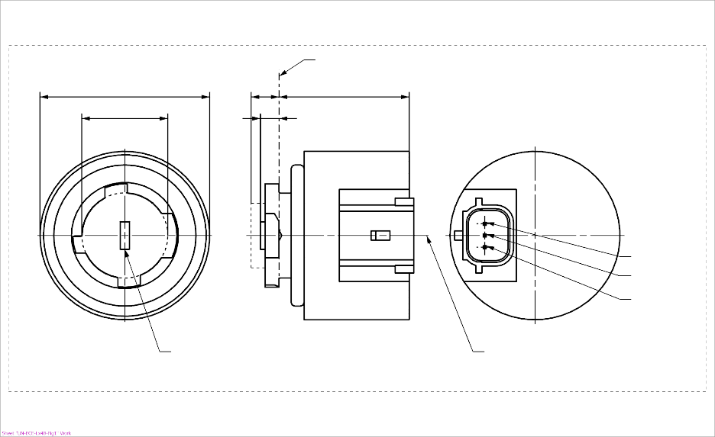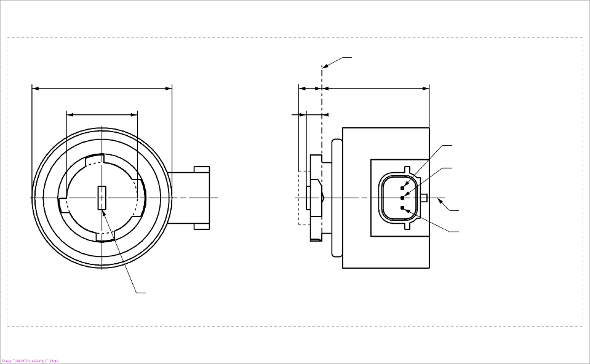
b
c
d
e
a
LRR8B
Ground
Reference axis²
Major Function
Minor Function
Reference plane¹

Light emitting area³
c
a
e
d
Reference plane¹
Major Function

Minor Function
Reference axis²
Ground

b
Light emitting area³
LRR8A
⁴
⁴

* Projection method:

For the notes see sheet LRR8/2
Categories LRR8A, LRR8B Sheet LRR8/2
Table 1
Essential dimensional, electrical and photometric characteristics of the LED light source

Dimensions |  |  |  |  |  | Production LED light sources |  |  |  | Standard LED light sources
a |  |  |  |  | mm | 6.0 max.
b |  |  |  |  | mm | c + 10.0 min.  38.0 max.
c |  |  |  |  | mm | 18.5 ± 0.1
d |  |  |  |  | mm | 28.0 max.
e ^{8/} |  |  |  |  | mm | 3.0 ± 0.30 |  |  |  | 3.0 ± 0.15
Cap | LRR8A, LRR8B |  | PGJ18.5t-1 |  | in accordance with IEC Publication 60061 (sheet 7004-185-3)
Electrical and photometric characteristics
 |  |  |  |  |  | Minor function |  | Major function | Minor function |  | Major function
Rated values |  | Volts |  |  |  | 12 |  |  | 12
 |  | Watts |  |  |  | 1.0 | 4.0 |  | 1.0 |  | 4.0
Test voltage |  | Volts (DC) |  |  |  | 13.5 |  |  | 13.5
Objective Values ⁶ |  | Watts (at test voltage) |  |  |  | 1.0 max. | 4.5 max. |  | 1.0 max |  | 4.5 max
 |  | Luminous flux (in lm at test voltage) ^{5, 10, 11} |  |  |  | 10 ± 30% | 120 ± 20 % ⁷ |  | 10 ± 20% ⁹ |  | 120 ± 10 % ⁷
 |  | Luminous flux (in lm at 9 V DC) ⁵ |  |  |  | 2 min | 28 min
^{1/} The reference plane is the plane defined by the contact points of the cap-holder fit.
^{2/} The reference axis is perpendicular to the reference plane and passing through the centre of the bayonet core.
^{3/} Light emitting area: to be checked by means of the box system in Figure 2
^{4/} A minimum free air space of 5 mm around the light source shall be respected for convection; the connector interface can be neglected.
^{5/} The emitted light shall be red.
^{6/} After continuous operation for 30 minutes at 23 ± 2.5° C.
^{7/} The measured value shall be in between 100 per cent and 70 per cent of the value measured after 1 minute.
^{8/} Light centre length; the major function is operated during the measurement; for the method of measurement, see Annex K of IEC 60809, Edition 4.
^{9/} The measured value shall be in between 110 per cent and 90 per cent of the value measured after 1 minute.
^{10/} When minor and major functions are powered at the same time, the luminous flux shall not be less than the minimum objective value of the major function (96 lm) and shall not be more than the maximum objective value given by the sum of both functions (157 lm).
^{11/} No light shall be emitted in the case the light source LRR8A is powered with a connector counterpart having the pin assignment of the light source LRR8B, and vice versa

Electrical characteristics
In case of LED light source failure (no light emitted) the max. electrical current draw, when operated between 12 V and 14 V, shall be less than 20 mA (open circuit condition).

Categories LRR8A, LRR8B Sheet LRR8/3
Screen projection requirements
The following test is intended to define the requirements for the light emitting area of the LED light source and to determine whether the light emitting area is correctly positioned relative to the reference axis and reference plane in order to check compliance with the requirements.
The position of the light emitting area is checked by the box system defined in Figure 2, which is aligned to the planes C₉₀ and C₁₈₀ and shows the projection when viewing along direction γ = 0º at e = 3.0 mm (C, γ as defined in Figure 3).
The luminous flux Φ emitted into the viewing direction shall be calculated as given below:

$$Φ=L⋅S⋅Ω$$
with
S = area to be considered
L = luminance average of area S
Ω = solid angle defined by the entrance aperture of the measurement system
The distribution of luminous flux originating from the LEA as shown in Figure 2 shall fulfil the requirements given in Table 3. All numbers shall be given in % of the total luminous flux emitted into the viewing direction from the bayonet core area, i.e. a circular area with diameter c = 18.5 mm (see Figure 1).
Note: When evaluating the luminous flux distribution emitted from the LEA, reflections and stray light within the measurement equipment shall be reduced as much as possible and if necessary, corrected. More details regarding measurement of light-emitting areas can be found in the publication describing general photometry accuracy guidelines currently prepared by CIE TC2-67

Figure 2

Box definition of the light emitting area with dimensions as specified in Table 2

Reference axis perpendicular in
the centre of the light-emitting area
C₂₇₀
C₁₈₀
C₉₀
C₀

f/3
f/3
f/3
f/3
f/3
f/3
A
B
B
B
B
C
C
C
C
f/2
f/2

Table 2

Dimensions of the box system in Figure 2

Dimensions in mm | f
LED light sources of normal production | 4.5
Standard LED light sources | 4.5
CATEGORIES LRR8A, LRR8B Sheet LRR8/4

Table 3

Proportion of the total luminous flux emitted into the viewing direction from the areas specified in Figure 2

Area(s) | LED light sources of normal production  for minor function and major function | Standard LED light sources  for minor function and major function
Each B individually | ≥10% | ≥15%
Each A, B individually | < 40% | < 30%
All B together | ≥ 60% | ≥ 65%
Each C individually | - | < 10%
All A, B and C together | ≥ 90% | ≥ 90%

Categories LRR8A, LRR8B Sheet LRR8/5
Normalized luminous intensity distribution
The following test is intended to determine the normalized luminous intensity distribution of the light source in an arbitrary plane containing the reference axis. The intersection of the reference axis and the parallel plane to the reference plane in distance e = 3.0 mm is used as the coordinate system origin.
The light source is mounted on a flat plate with the corresponding mounting lug features. The plate is mounted to the goniometer table by a bracket, so that the reference axis of the light source lines up with one of the rotating axes of the goniometer. The corresponding measurement set-up is described in Figure 3.
Luminous intensity data is recorded with a standard photo-goniometer. The measurement distance should be chosen appropriately, to make sure that the detector is located in the far field of the light distribution.
The measurements shall be performed in C-planes C₀, C₉₀, C₁₈₀ and C₂₇₀, which contain the reference axis of the light source. The test points for each plane for multiple polar angles γ are specified in Table 4.
The measured luminous intensity values, normalised to the measured luminous flux of the individual light source under test, shall be converted to normalised luminous intensity values of a 1,000 lm light source. The data shall comply with the tolerance band as defined in Table 4.
The drawings are intended only to illustrate the essential set-up for measurement of the LED light source.

Figure 3

Set-up to measure the luminous intensity distribution

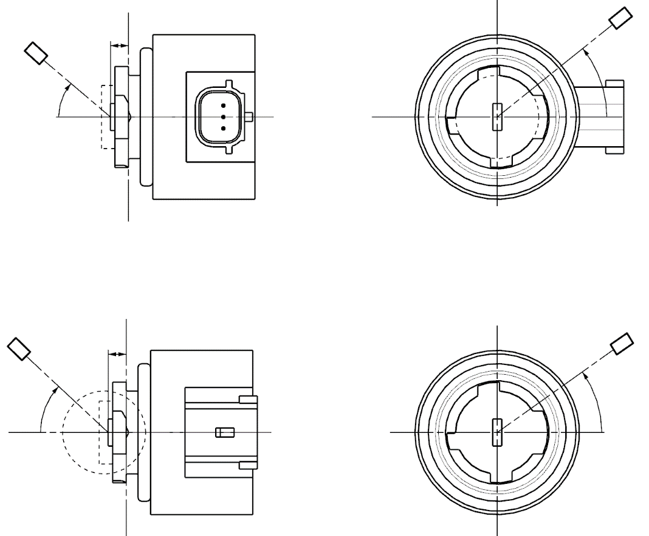
Reference axis
Reference plane
Photo-Detector of Goniometer
C-plane definition
Viewing direction along reference axis
LRR8B
Reference axis
Reference plane
C-plane definition
Viewing direction along reference axis
Photo-Detector of Goniometer
LRR8A
C
γ
e
C₀
C
γ
e
C₀
Categories LRR8A, LRR8B Sheet LRR8/6
The light pattern as described in Table 4 shall be substantially uniform, i.e. in between two adjacent grid points the relative luminous intensity requirement is calculated by linear interpolation using the two adjacent grid points. In case of doubt this may be checked in addition to verification of the grid points given in Table 4.

Table 4
Test point values of normalized intensities

 | LED light sources of normal production  for minor function and major function |  | Standard LED light sources  for minor function and major function
Angle γ | Minimum Intensity  in cd /1000 lm | Maximum Intensity  in cd/1000 lm | Minimum Intensity  in cd /1000 lm | Maximum Intensity in cd /1000 lm
0° | 200 | 425 | 250 | 390
15° | 190 | 415 | 240 | 370
30° | 170 | 380 | 220 | 335
45° | 145 | 310 | 180 | 275
60° | 85 | 245 | 105 | 220
75° | 0 | 160 | 0 | 150
90° | 0 | 70 | 0 | 65

"

* In accordance with the programme of work of the Inland Transport Committee for 2026 as outlined in proposed programme budget for 2026 (A/80/6 (Sect. 20), table 20.7), the World Forum will develop, harmonize and update UN Regulations in order to enhance the performance of vehicles. The present document is submitted in conformity with that mandate.

